1: Create a customized Docker image using a Dockerfile.
Step 1: Clone Repo
git clone https://github.com/betawins/Python-app.git
cd Python-app
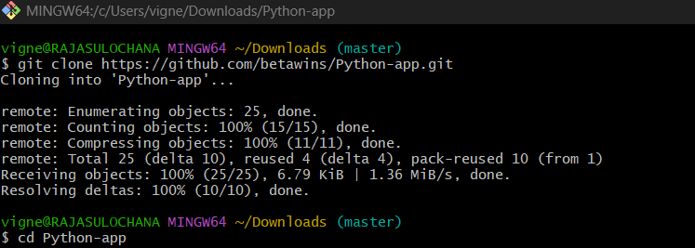
Step 2: Create Dockerfile
vi Dockerfile
# Base image
FROM python:3.9-slim
# Set working directory
WORKDIR /app
# Copy files
COPY . .
# Install dependencies
RUN pip install -r requirements.txt
# Expose port
EXPOSE 5000
# Run app
CMD ["python", "app.py"]

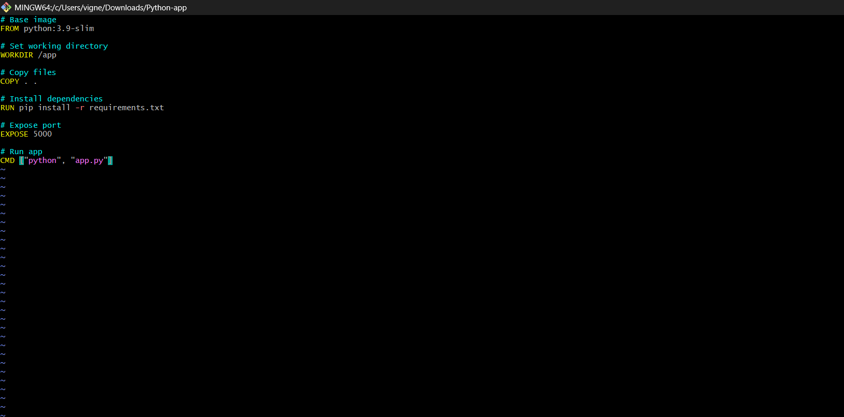

Step 3: Build Image
docker build -t yourdockerhubusername/python-app:v1 .
docker build -t vigneshadlagatta7/python-app:v1 .
What this command means
- docker build → creates image from Dockerfile
- -t → tag (name + version)
- vigneshadlagatta7/python-app → repo name (Docker Hub format)
- v1 → version tag
- . → current directory (where Dockerfile exists)
What happens internally
- Docker reads your Dockerfile
- Pulls base image → python:3.9-slim
- Creates /app directory
- Copies your files
- Installs dependencies
- Builds final image
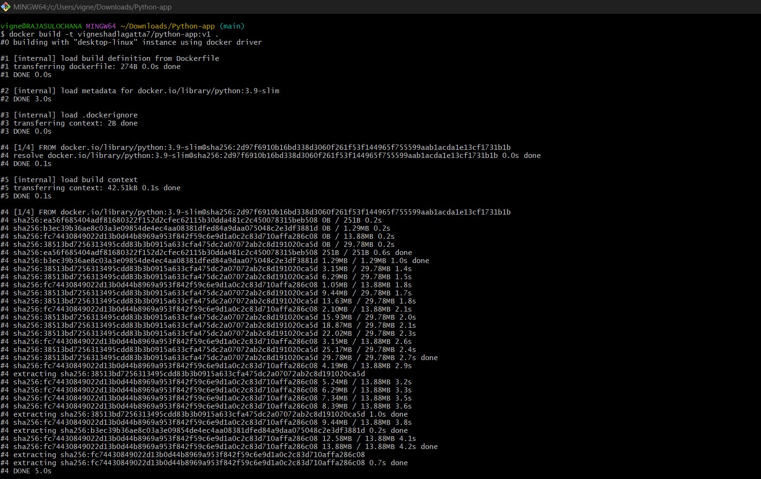

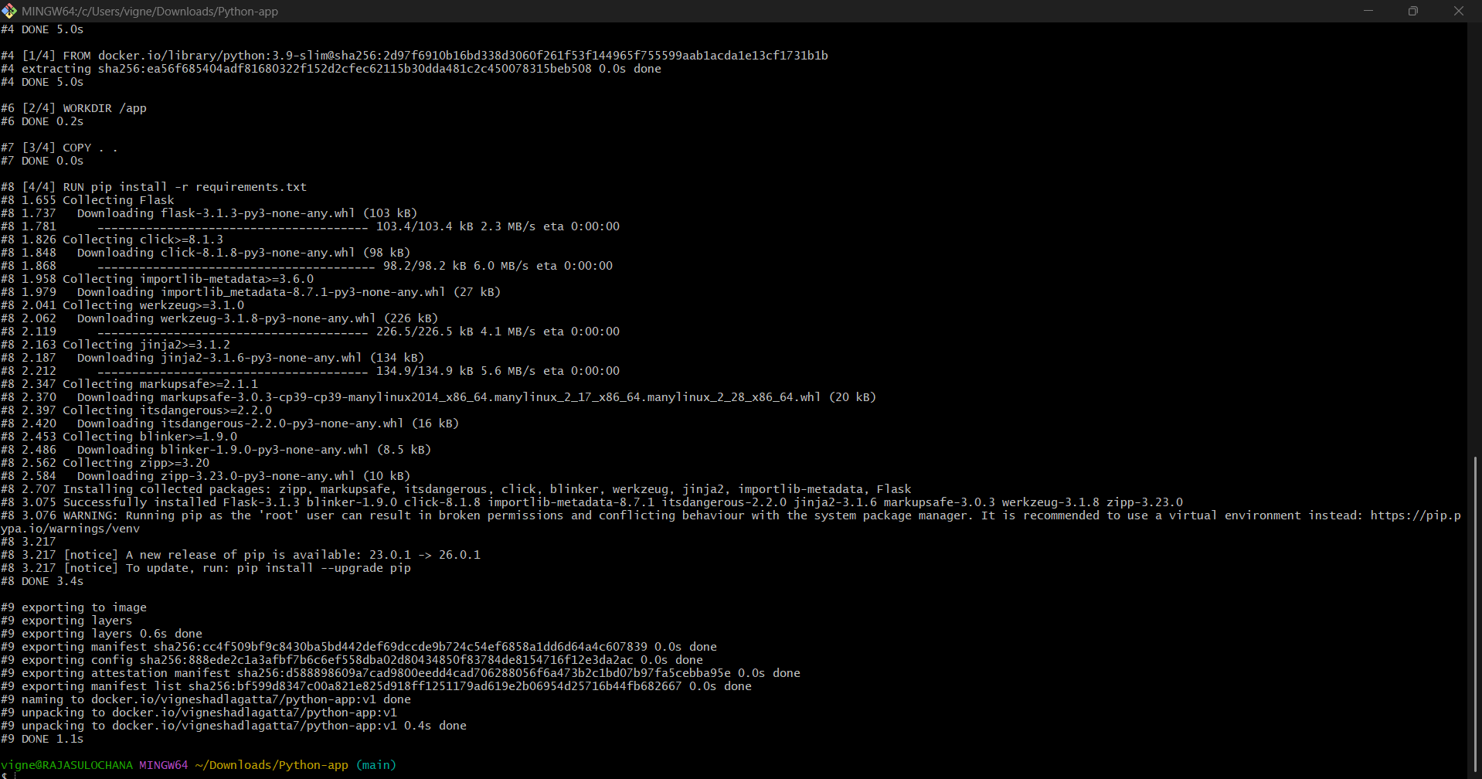

Step 4: Run Container
docker run -d -p 5000:5000 vigneshadlagatta7/python-app:v1
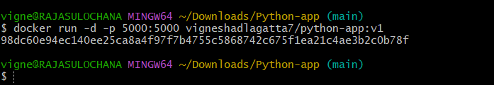

docker ps

Output should show something like:
CONTAINER ID IMAGE PORTS
98dc60e94ec1 vigneshadlagatta7/python-app:v1 0.0.0.0:5000->5000/tcp
✔️ If you see this → container is running

2. Check in Browser
Open:
http://localhost:5000

If your app is correct → you’ll see output (Flask app / response)
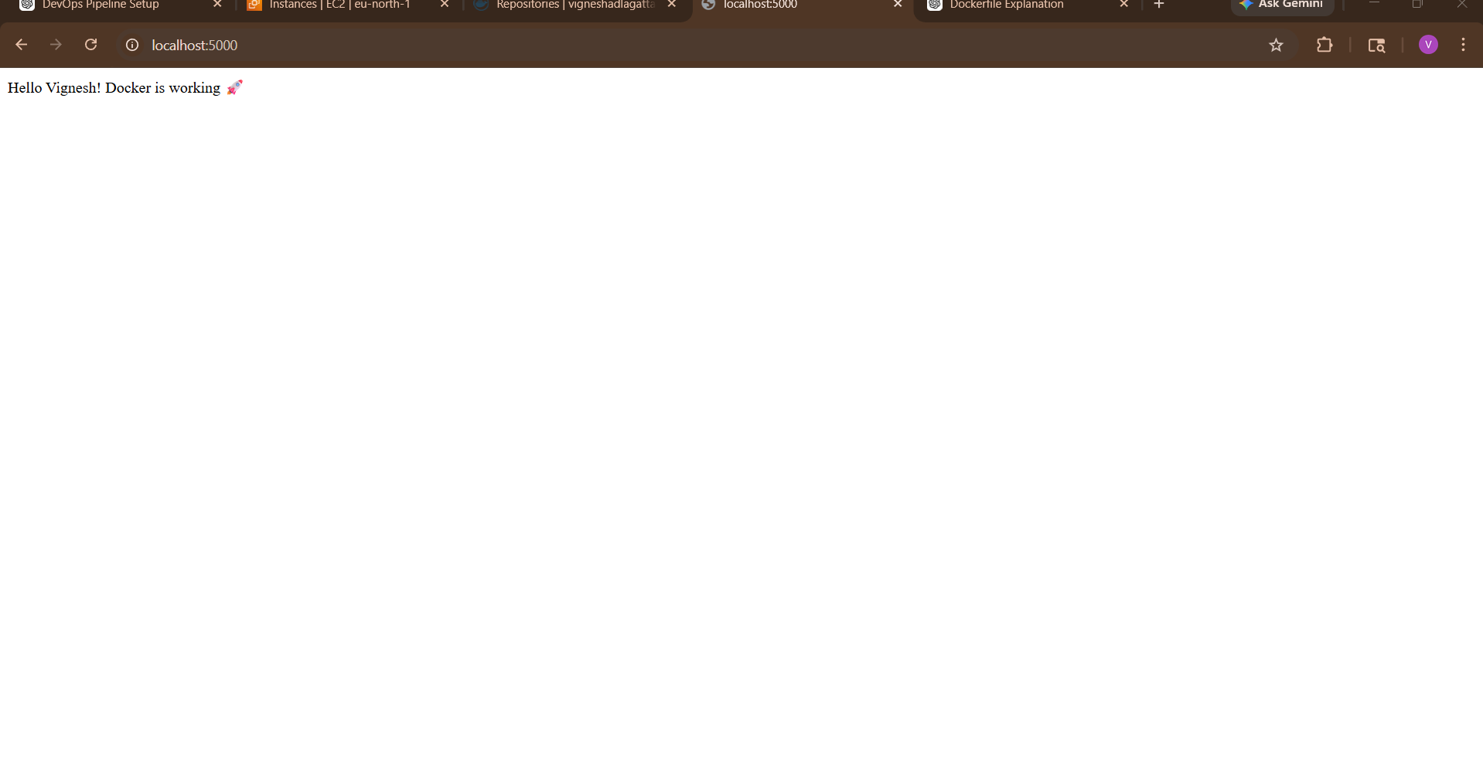

2) Push the image to Docker Hub.
docker login
docker push yourdockerhubusername/python-app:v1
docker push vigneshadlagatta7/python-app:v1
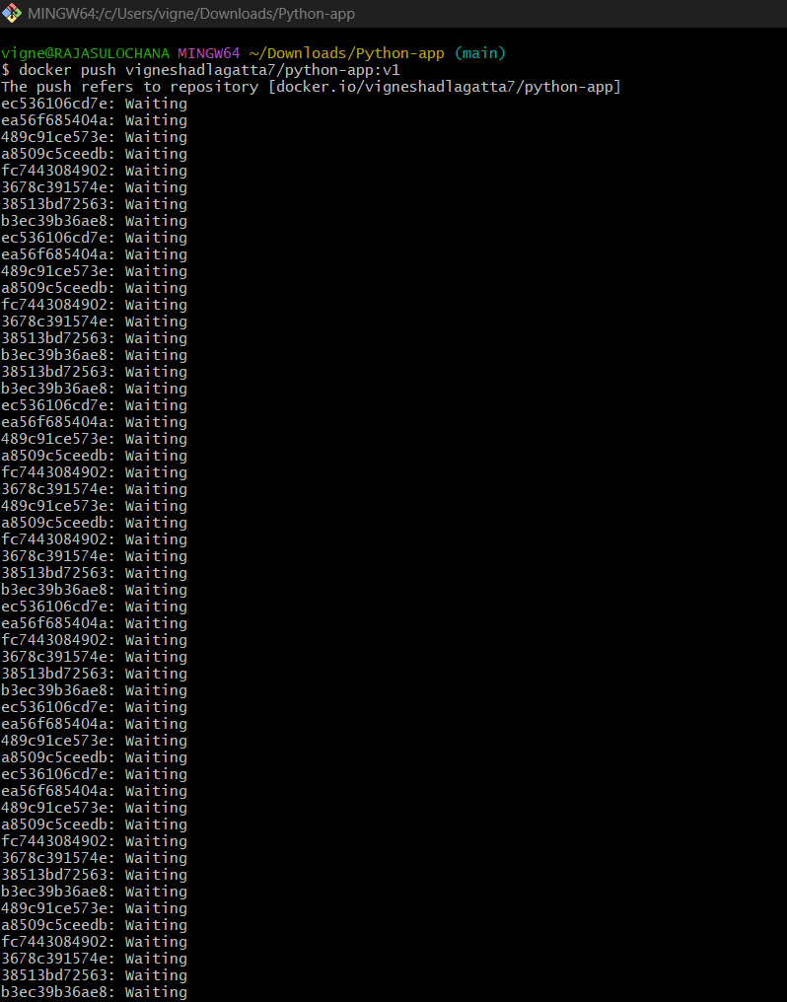
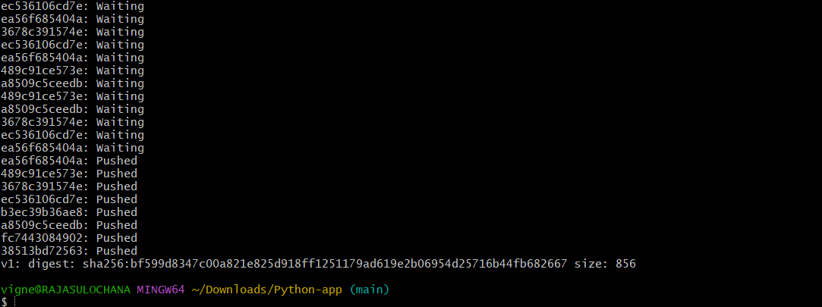

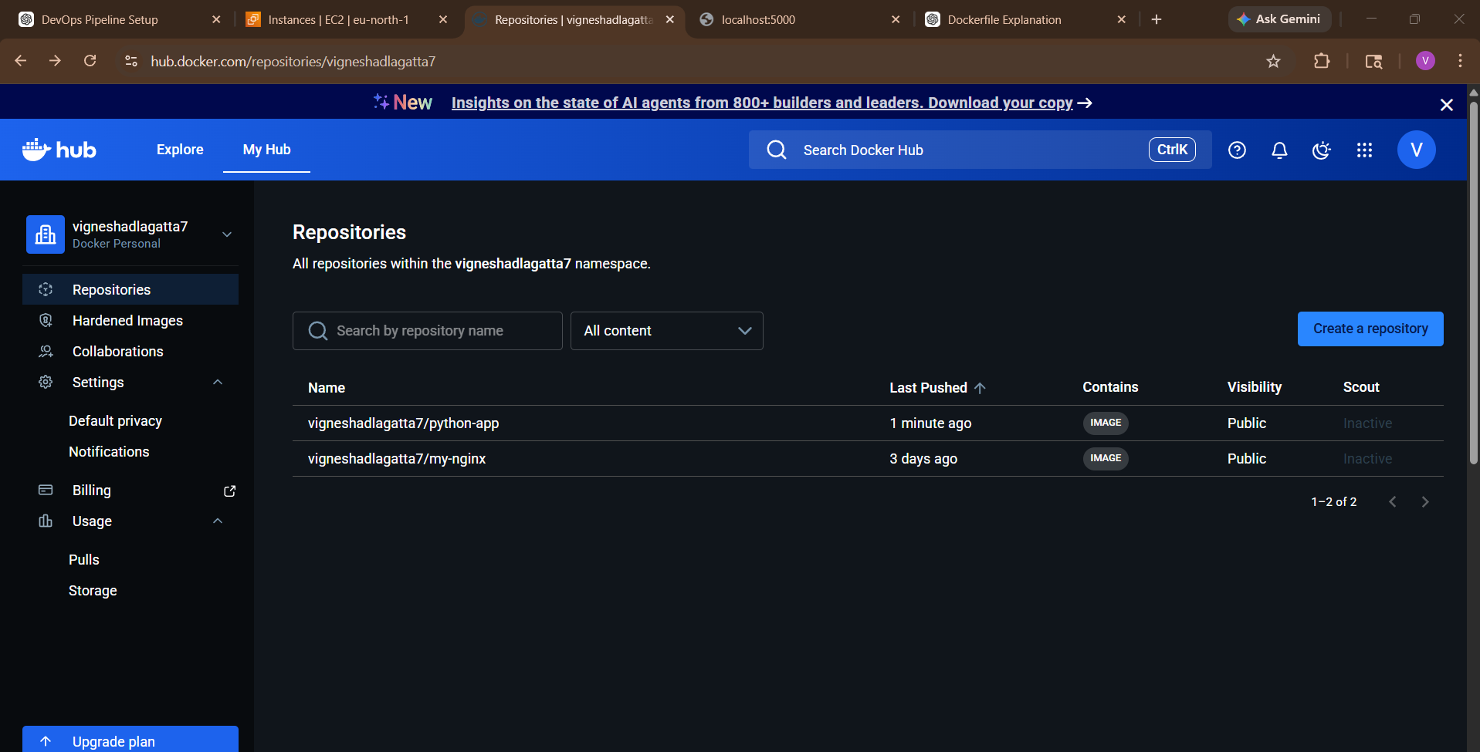

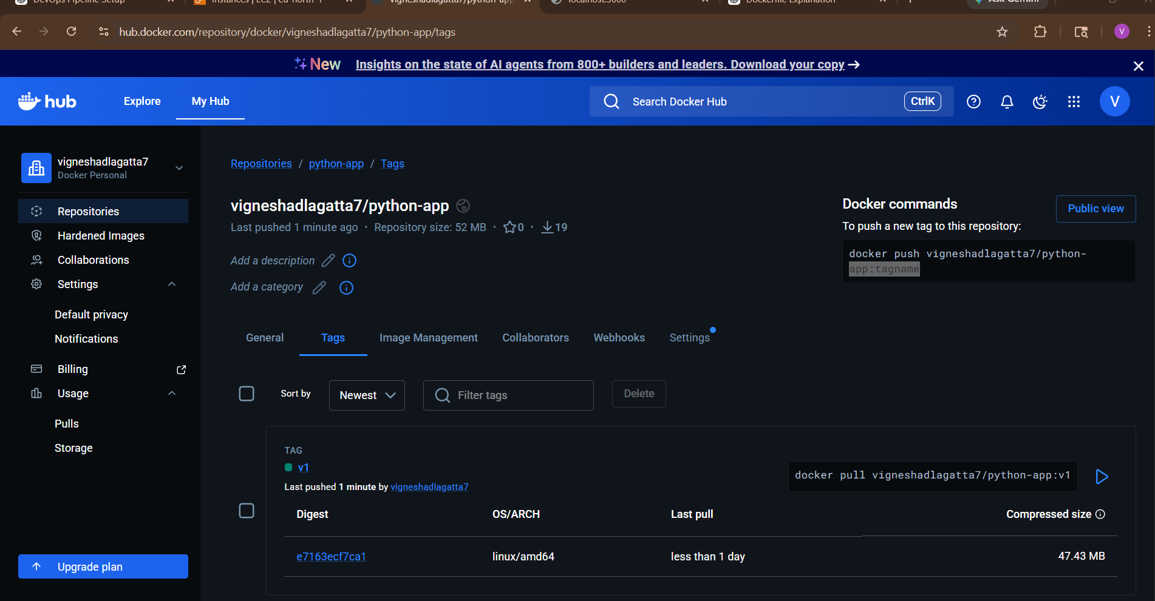
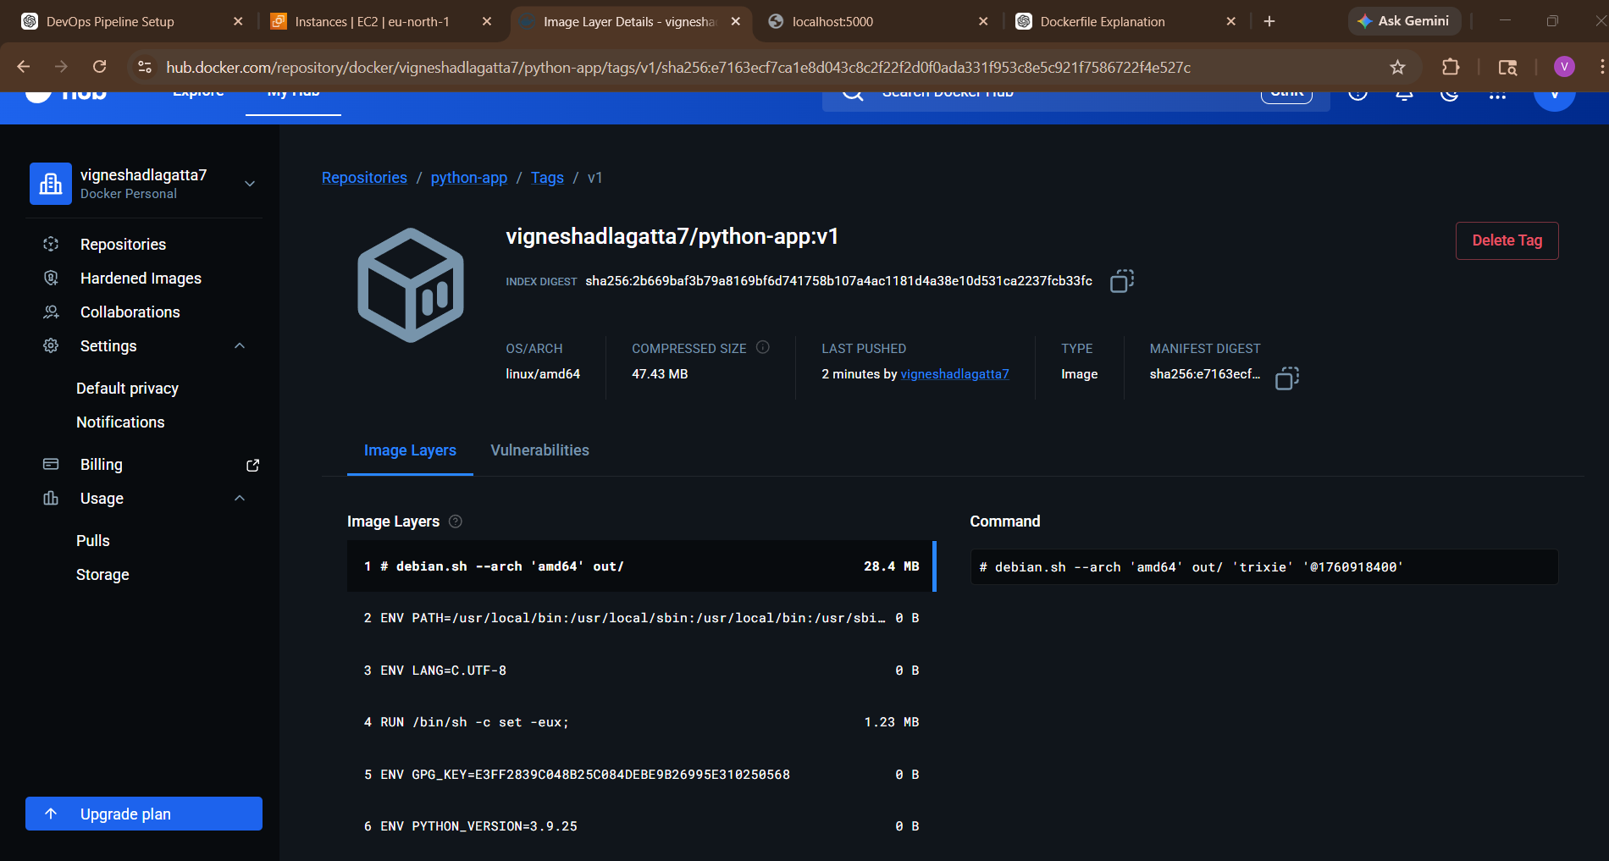

3)Push the same image to Amazon ECR.
Step 1: Configure AWS CLI
aws configure
Enter:
• Access Key
• Secret Key
• Region (example: eu-north-1)
• Output format: json
______________
Step 2: Create ECR Repository
aws ecr create-repository --repository-name python-app
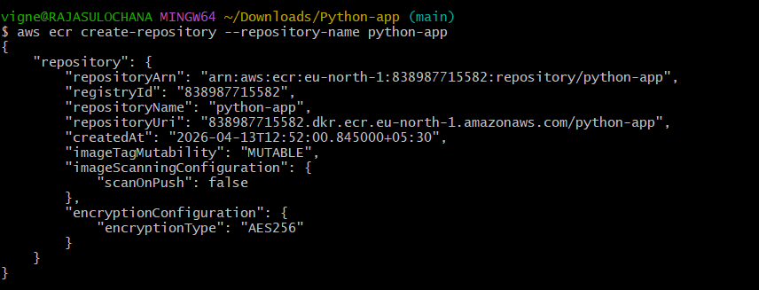
Step 3: Login to ECR
aws ecr get-login-password --region eu-north-1 | docker login --username AWS --password-stdin 838987715582.dkr.ecr.eu-north-1.amazonaws.com
Step 4: Tag Image for ECR
docker tag vigneshadlagatta7/python-app:v1 838987715582.dkr.ecr.eu-north-1.amazonaws.com/python-app:v1
Step 5: Push Image
docker push 838987715582.dkr.ecr.eu-north-1.amazonaws.com/python-app:v1
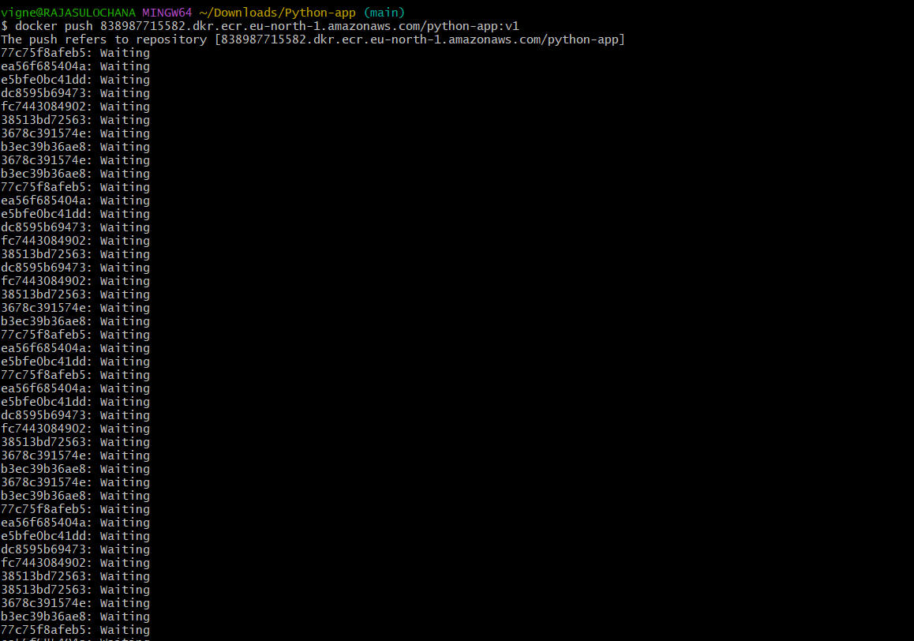
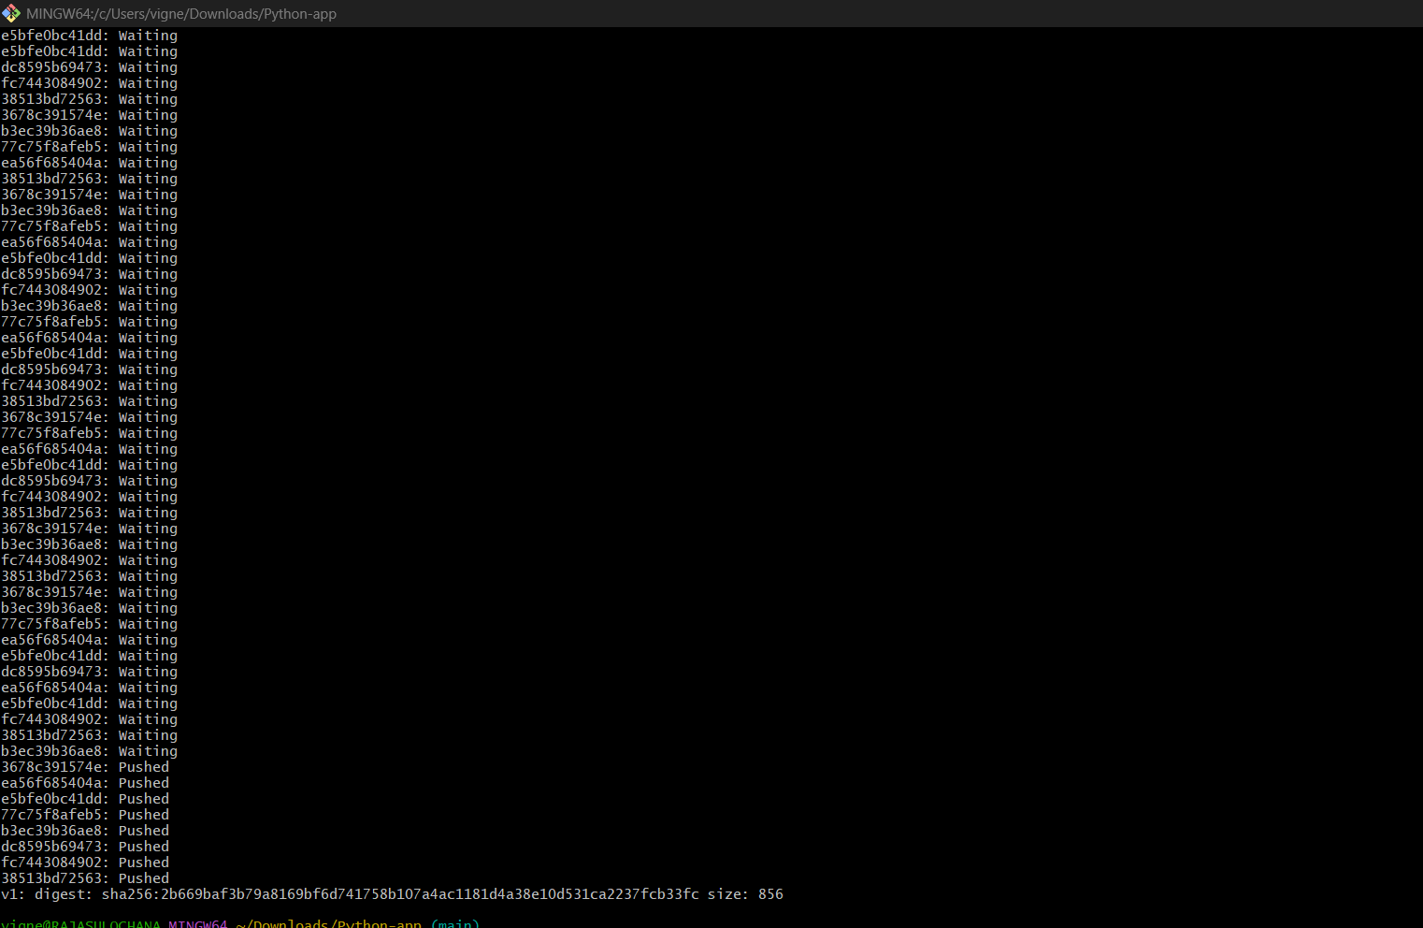

After Push Success
You’ll see:
v1: digest: sha256:xxxx
Now Check On AWS ECR
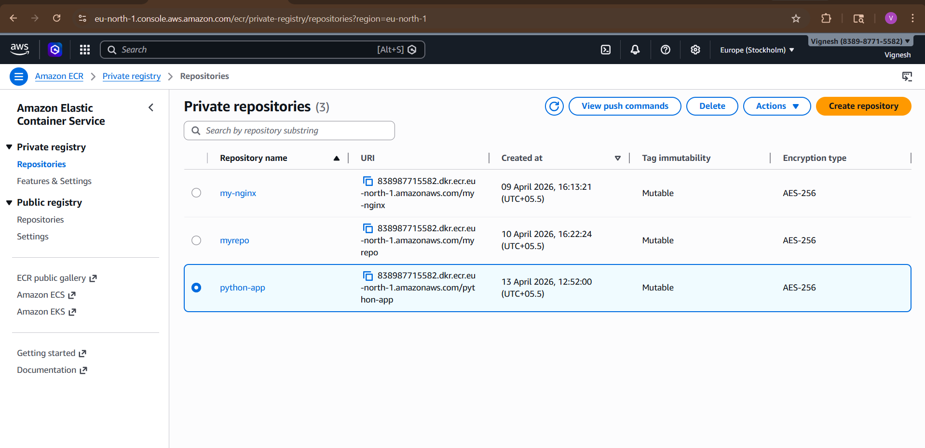
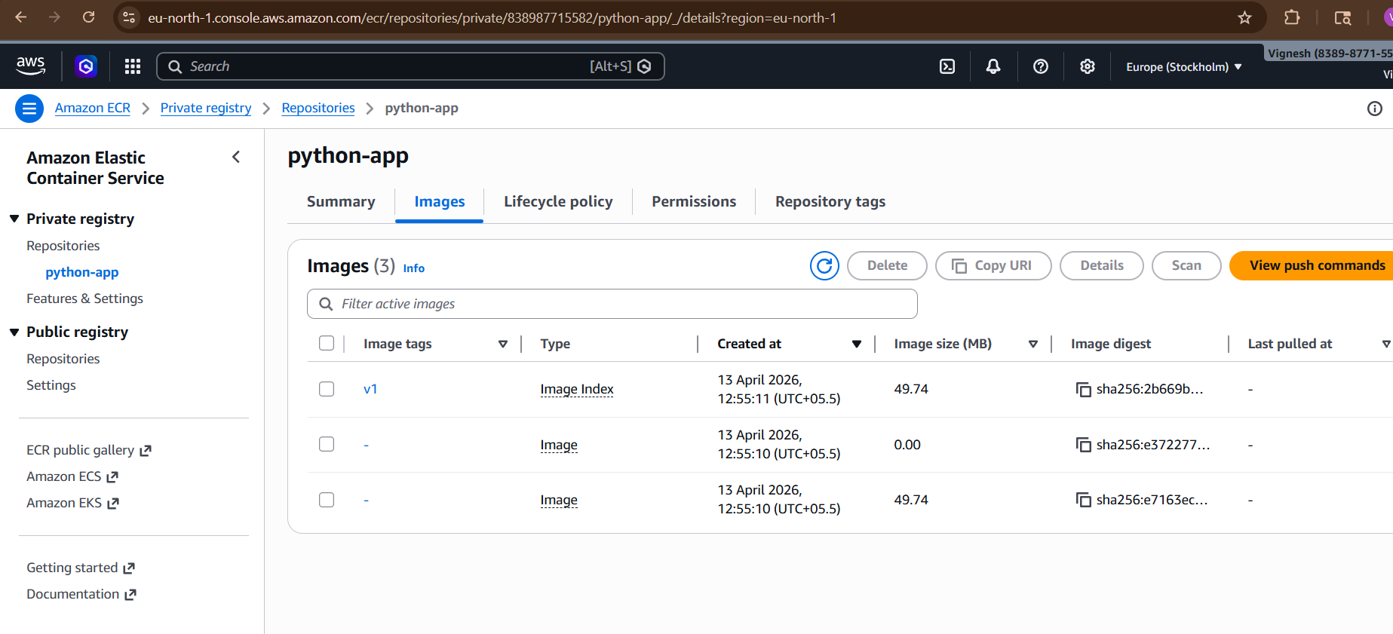
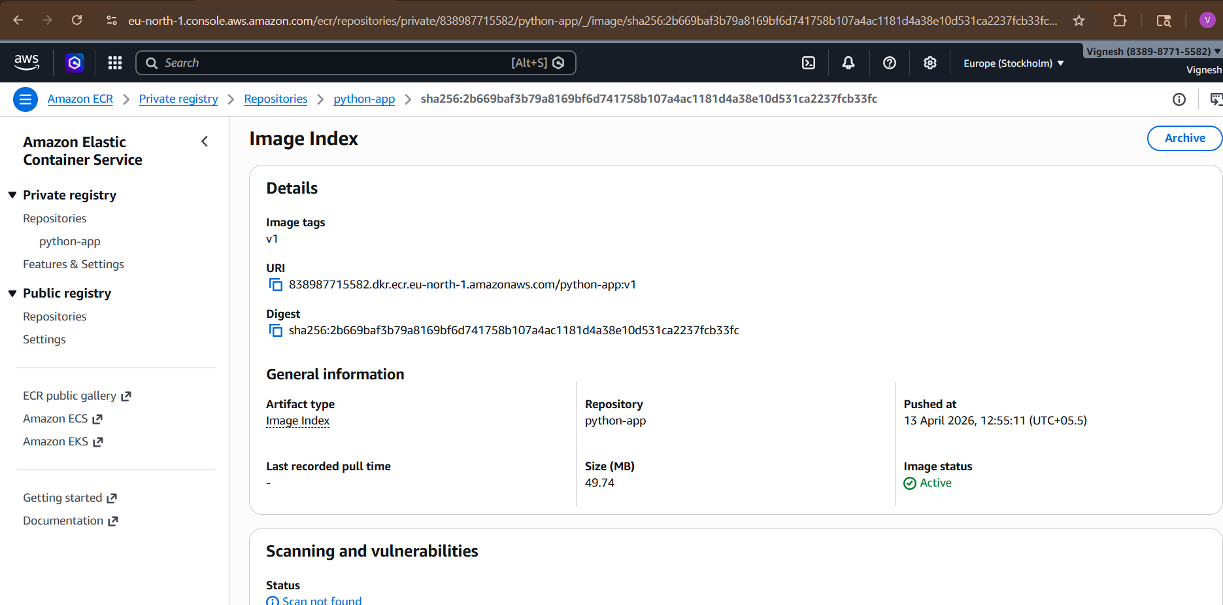

4) Provision one EC2 instance u sing Terraform and install Jenkins

Prerequisites
Step-by-Step Install Terraform
1️⃣ Install required packages
sudo yum install -y yum-utils
2️⃣ Add HashiCorp repo
sudo yum-config-manager --add-repo https://rpm.releases.hashicorp.com/AmazonLinux/hashicorp.repo
3️⃣ Install Terraform
sudo yum install terraform -y
4️⃣ Verify Installation
terraform -version
Output should be like:
Terraform v1.x.x
Step 1: Create Project Folder
mkdir terraform-jenkins
cd terraform-jenkins

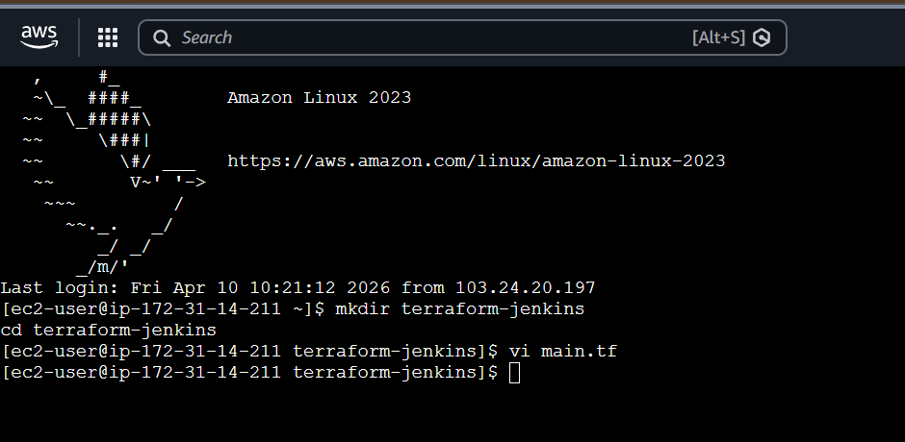
Step 2: Create main.tf File
vi main.tf

provider "aws" {
region = "ap-south-1"
}
# 🔐 Security Group
resource "aws_security_group" "jenkins_sg" {
name = "jenkins-sg"
description = "Allow SSH and Jenkins"
ingress {
from_port = 22
to_port = 22
protocol = "tcp"
cidr_blocks = ["0.0.0.0/0"]
}
ingress {
from_port = 8080
to_port = 8080
protocol = "tcp"
cidr_blocks = ["0.0.0.0/0"]
}
egress {
from_port = 0
to_port = 0
protocol = "-1"
cidr_blocks = ["0.0.0.0/0"]
}
}
# 🖥 EC2 Instance
resource "aws_instance" "jenkins_server" {
ami = "ami-0f5ee92e2d63afc18"
instance_type = "t2.micro"
key_name = "your-key" # ⚠️ replace with your key name (no .pem)
vpc_security_group_ids = [aws_security_group.jenkins_sg.id]
user_data = <<-EOF
#!/bin/bash
yum update -y
# Install Java 17
yum install -y java-17-amazon-corretto wget
# Set Java 17 as default
alternatives --set java /usr/lib/jvm/java-17-amazon-corretto/bin/java
# Add Jenkins repo
wget -O /etc/yum.repos.d/jenkins.repo https://pkg.jenkins.io/redhat-stable/jenkins.repo
rpm --import https://pkg.jenkins.io/redhat-stable/jenkins.io.key
# Install Jenkins
yum install -y jenkins
# Fix permissions (important)
mkdir -p /var/log/jenkins
chown -R jenkins:jenkins /var/lib/jenkins
chown -R jenkins:jenkins /var/log/jenkins
# Start Jenkins
systemctl daemon-reexec
systemctl start jenkins
systemctl enable jenkins
EOF
tags = {
Name = "Jenkins-Server"
}
}

Step 3: Run Terraform
terraform init

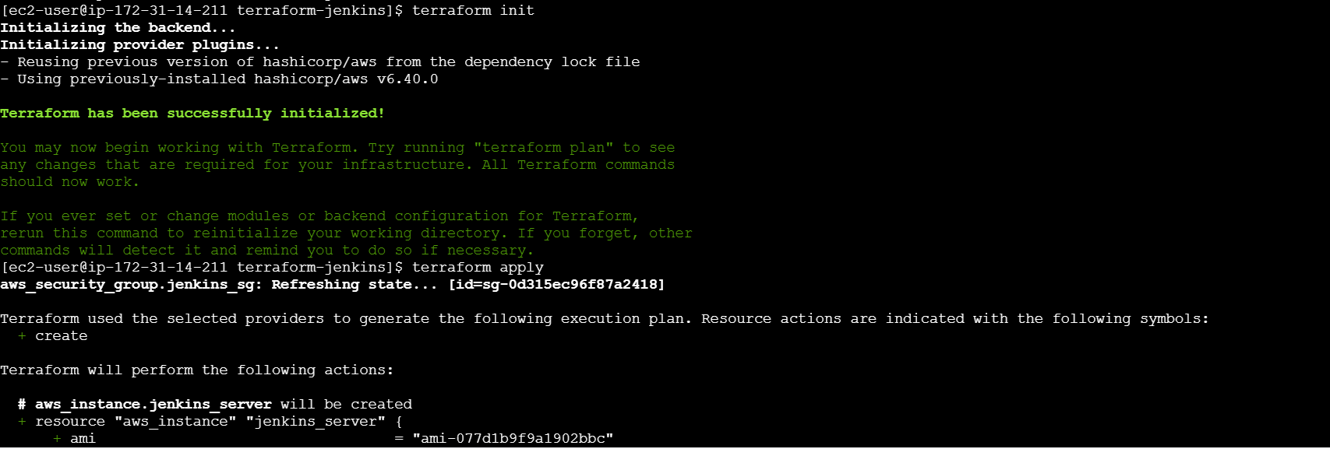

terraform apply

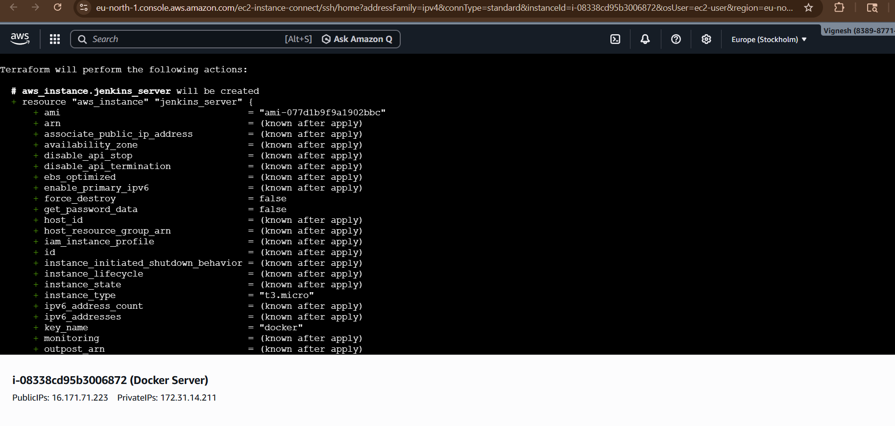
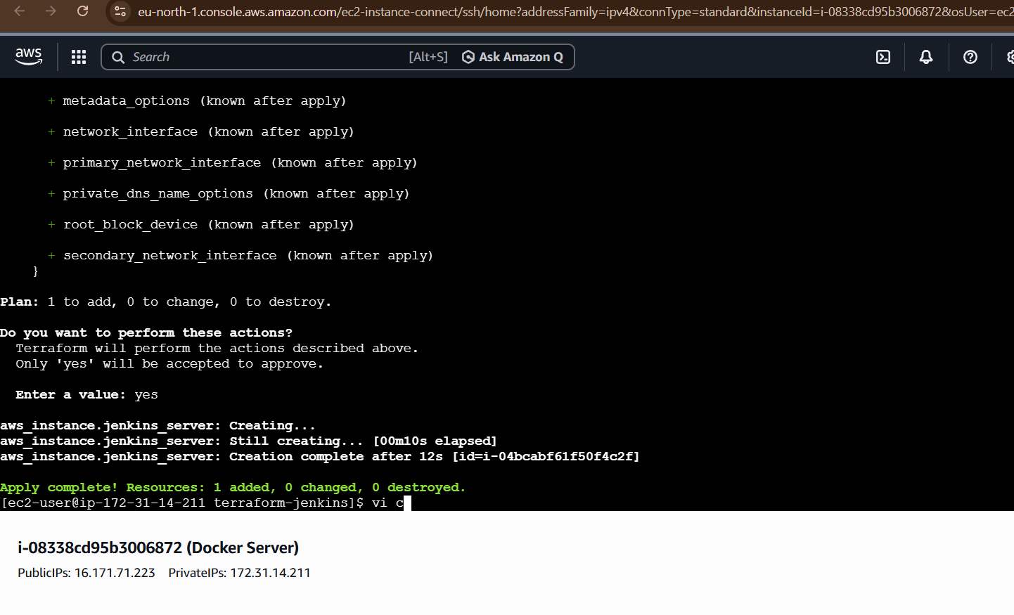

Verify IN AWS EC2

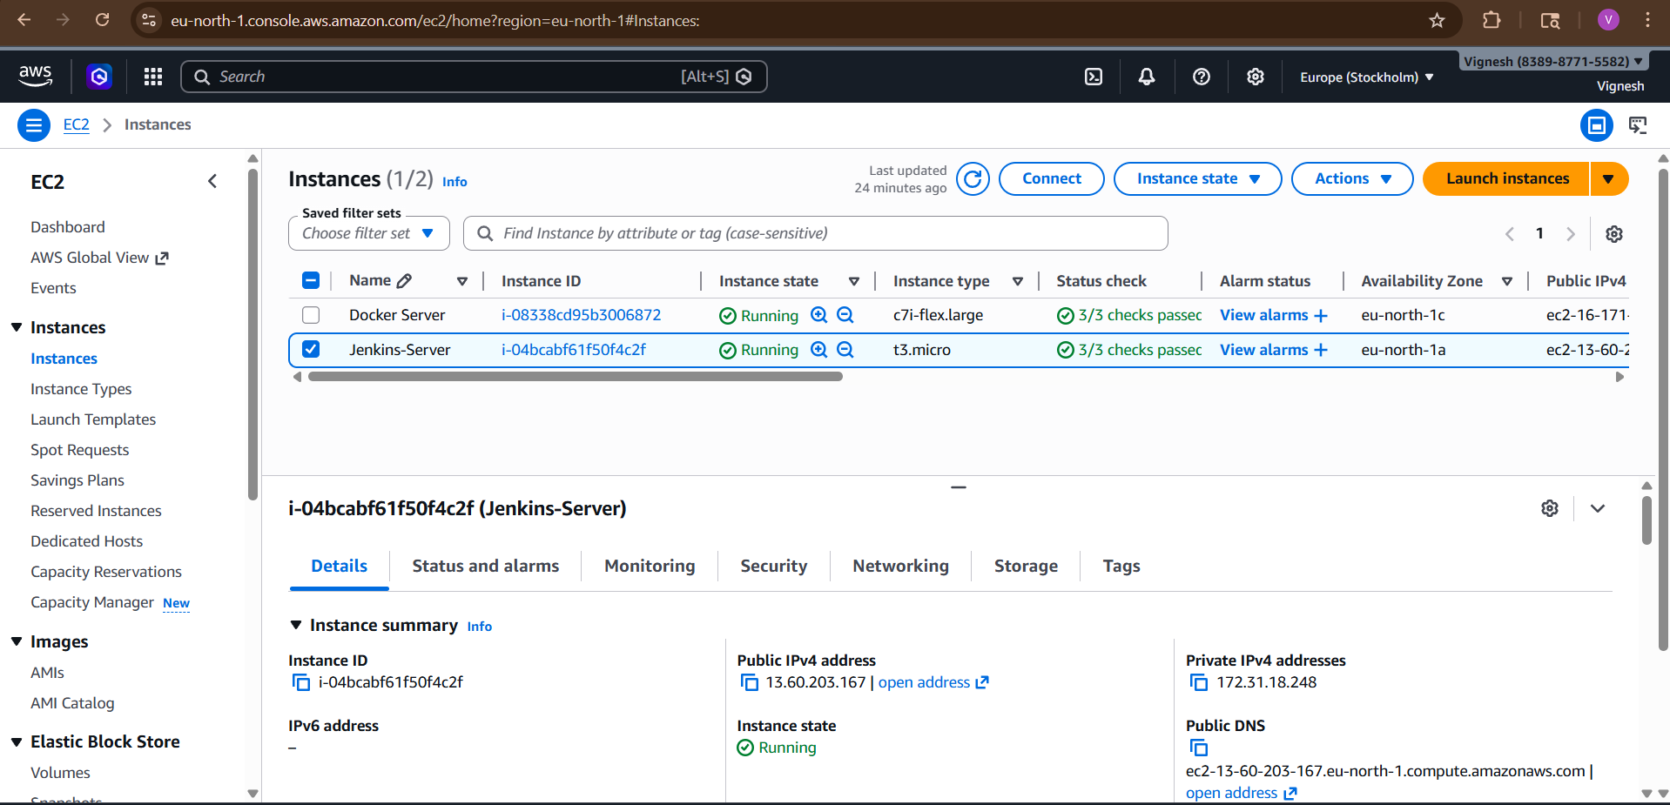

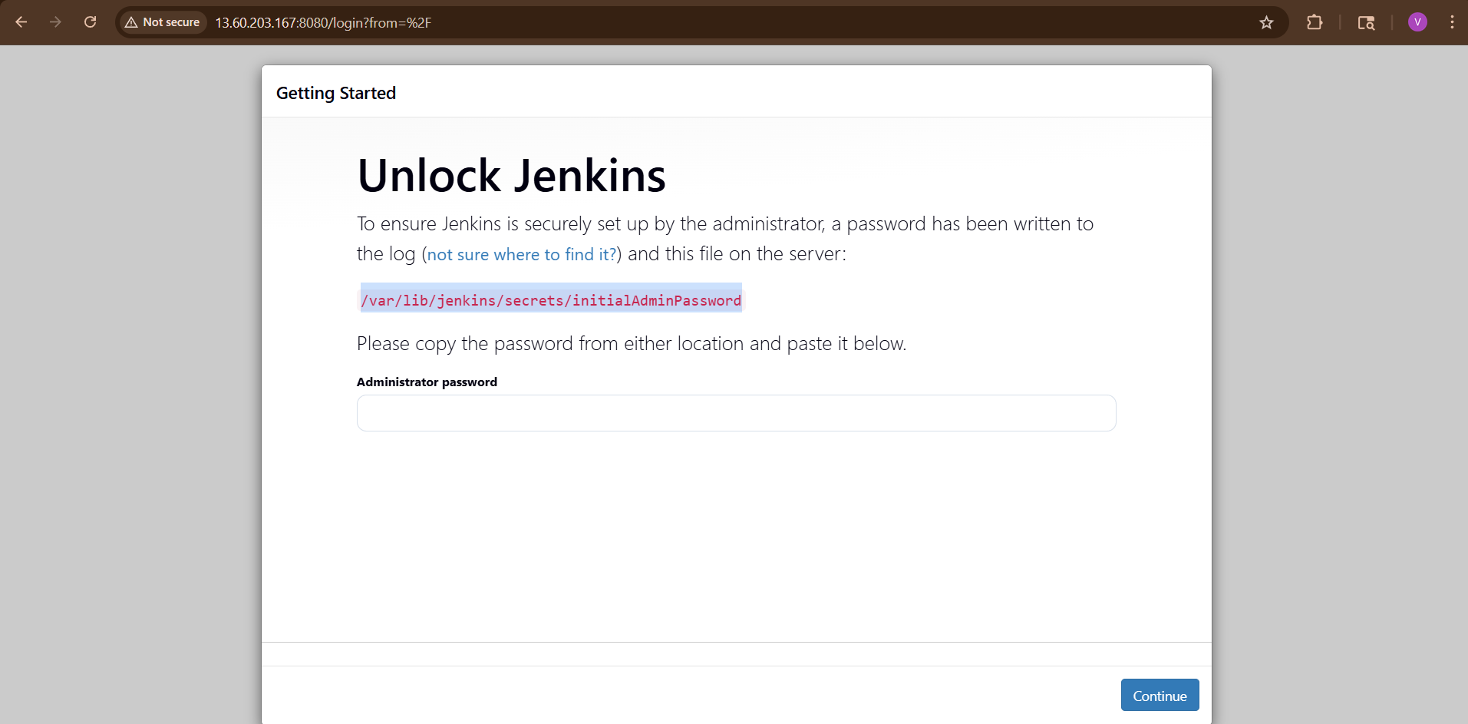

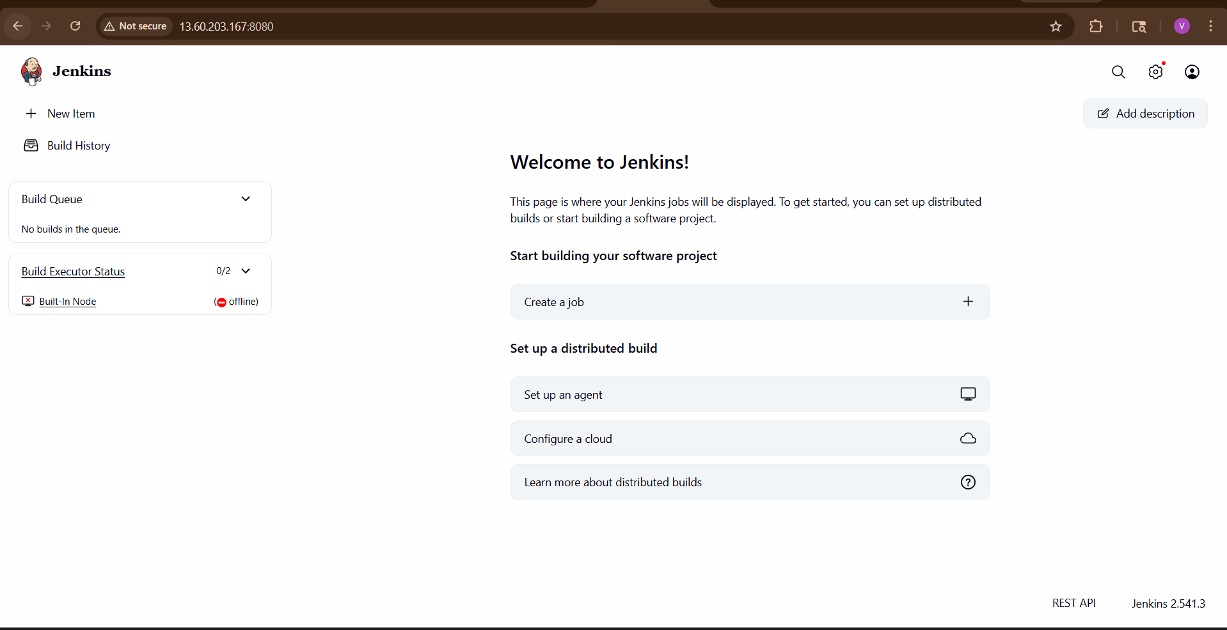

5) Create one Jenkins job to build and push the Docker image to Docker Hub.
Prerequisites
Make sure:
✔ Jenkins running (Docker or EC2)
✔ Docker installed inside Jenkins machine
✔ DockerHub account
✔ Git repo (your app)
Step 1: Install Required Tools in Jenkins
Go to Jenkins UI → Manage Jenkins → Plugins
Install:
- Docker Pipeline
- Git Plugin
Step 2: Add DockerHub Credentials
Go to:
Manage Jenkins → Credentials → Global → Add Credentials
Add:
- Username: your DockerHub username
- Password: DockerHub password / token
- ID: docker-cred
Step 3: Create Jenkins Job
New Item → Pipeline → Name: docker-pipeline
Step 4: Add Jenkinsfile
Paste this :

pipeline {
agent any
environment {
DOCKER_IMAGE = "vigneshadlagatta7/python-app"
DOCKER_TAG = "latest"
}
stages {
stage('Checkout Code') {
steps {
git branch: 'main', url: 'https://github.com/betawins/Python-app.git'
}
}
stage('Build Docker Image') {
steps {
script {
docker.build("${DOCKER_IMAGE}:${DOCKER_TAG}")
}
}
}
stage('Login to DockerHub') {
steps {
withCredentials([usernamePassword(
credentialsId: 'docker-cred',
usernameVariable: 'DOCKER_USER',
passwordVariable: 'DOCKER_PASS'
)]) {
sh "echo $DOCKER_PASS | docker login -u $DOCKER_USER --password-stdin"
}
}
}
stage('Push Docker Image') {
steps {
script {
docker.image("${DOCKER_IMAGE}:${DOCKER_TAG}").push()
}
}
}
}
post {
success {
echo "✅ Image pushed to DockerHub: vigneshadlagatta7/python-app"
}
failure {
echo "❌ Pipeline failed"
}
}
}

Now Run Pipeline
Click Build Now

Expected Result
✔ No “docker not found”
✔ Build success
✔ Image pushed to DockerHub

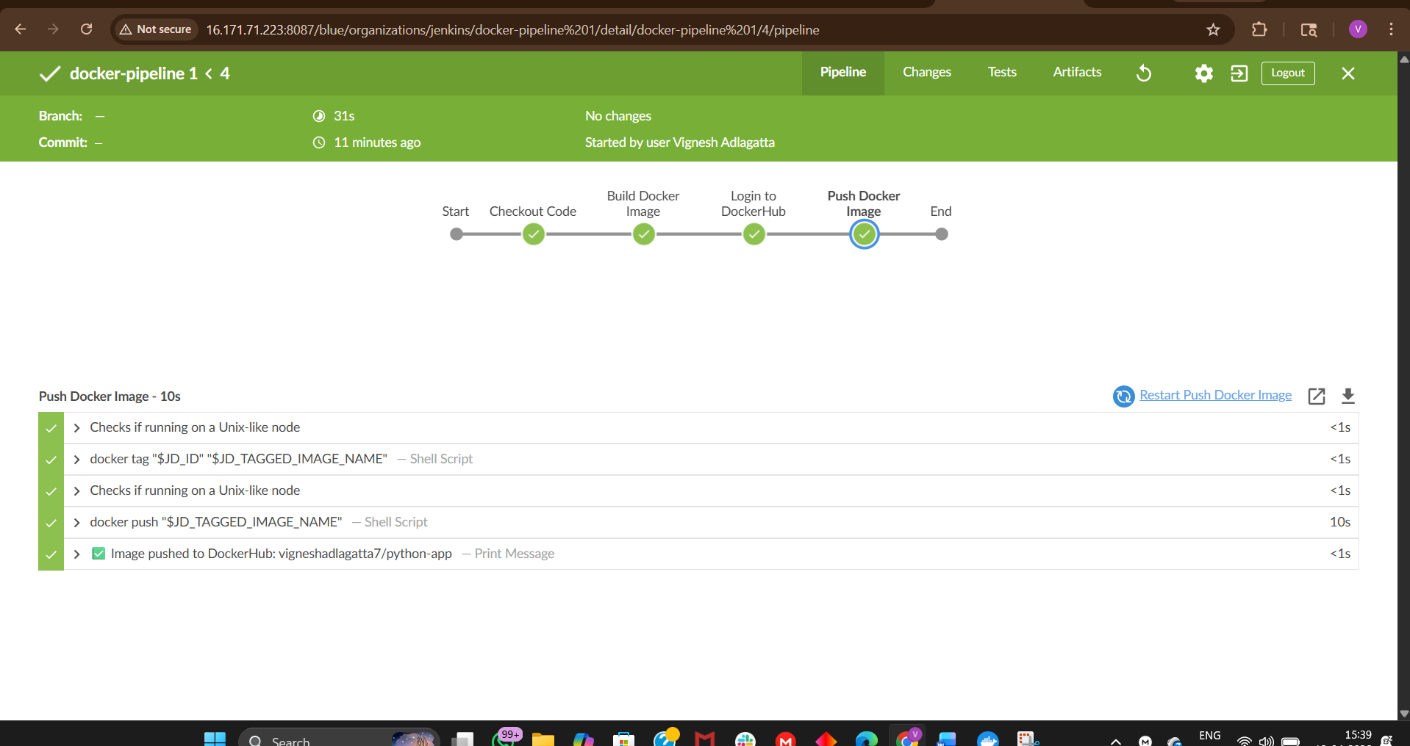

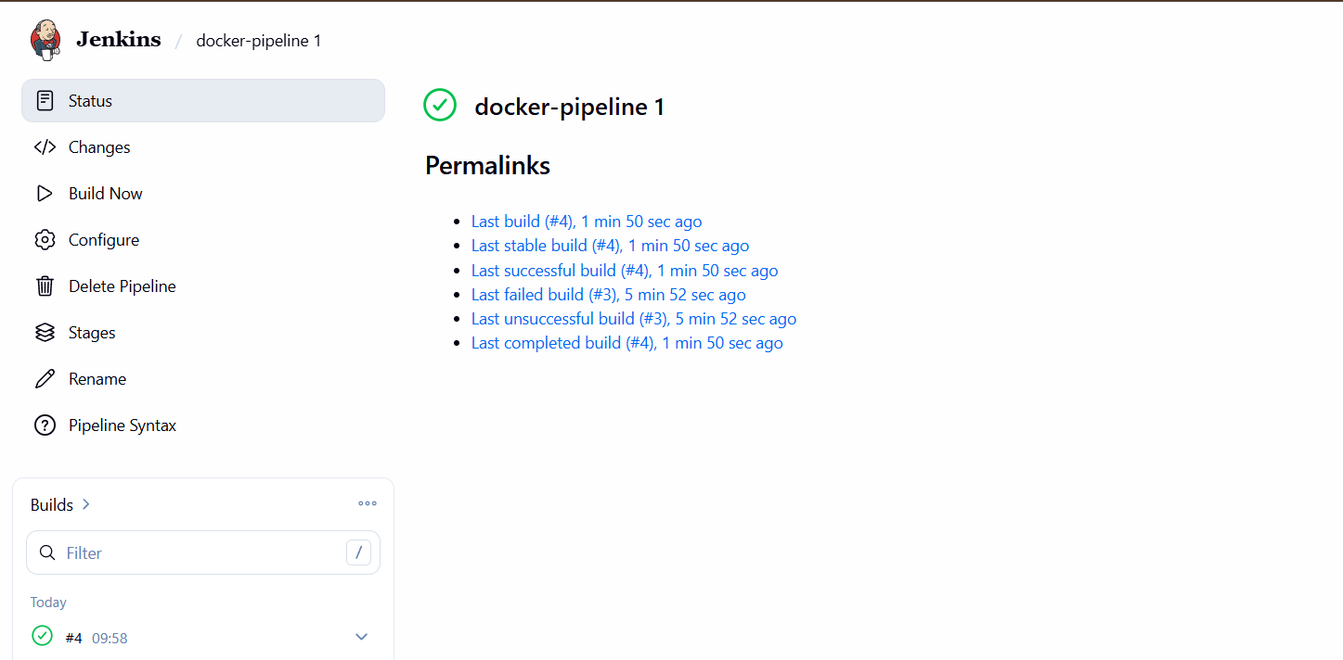
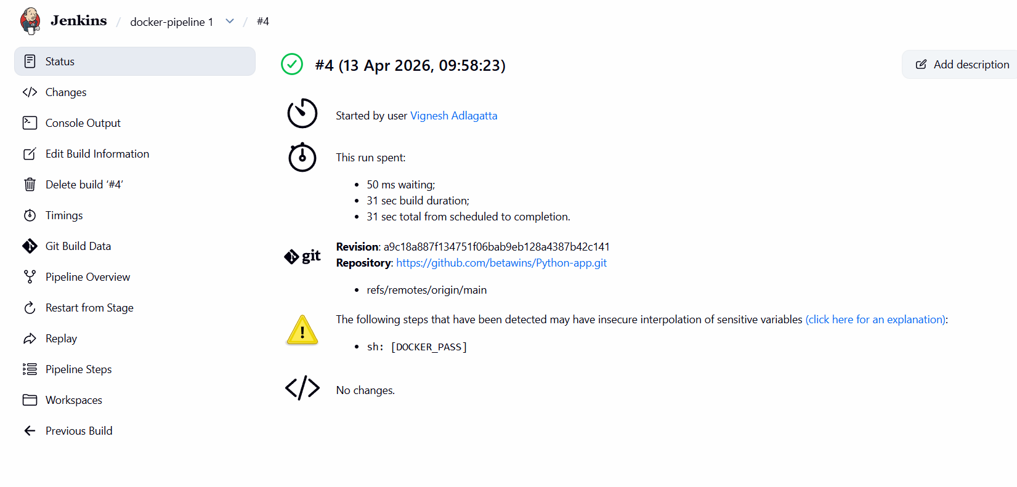

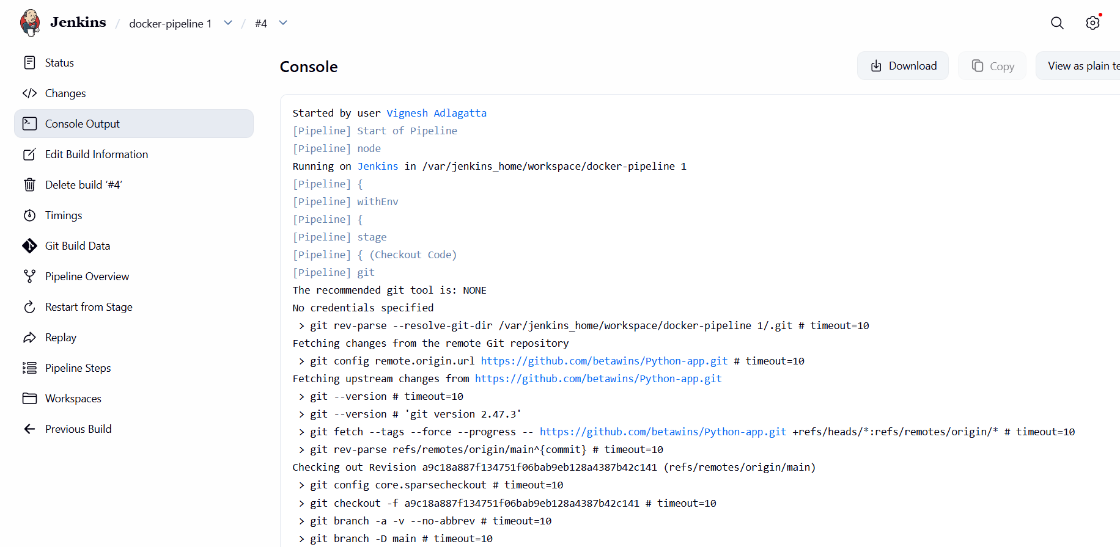

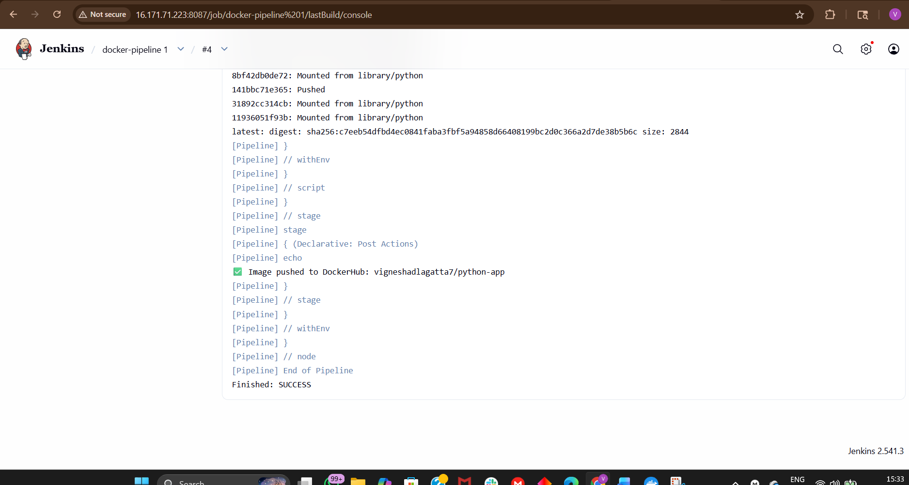

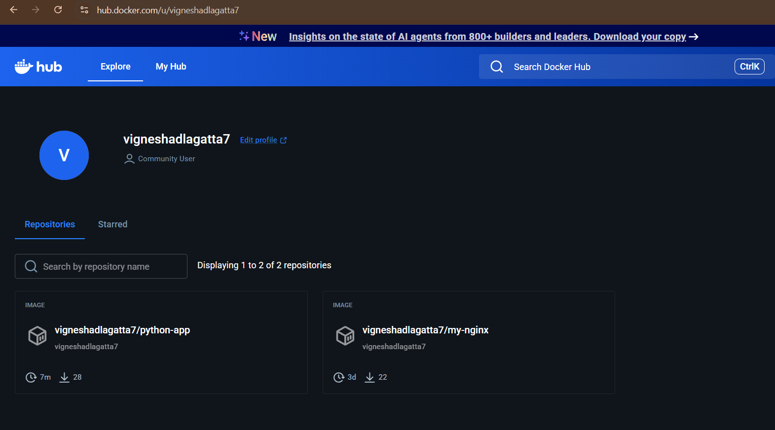
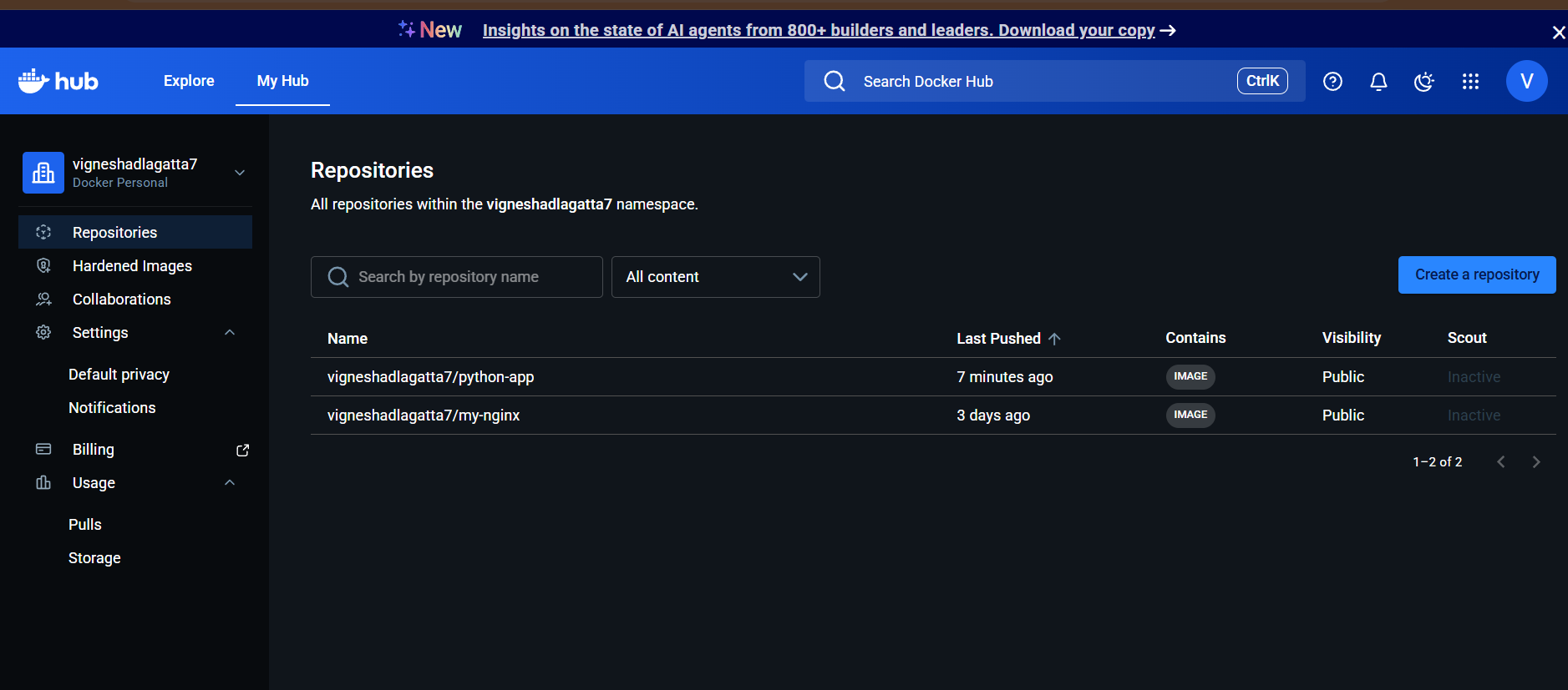
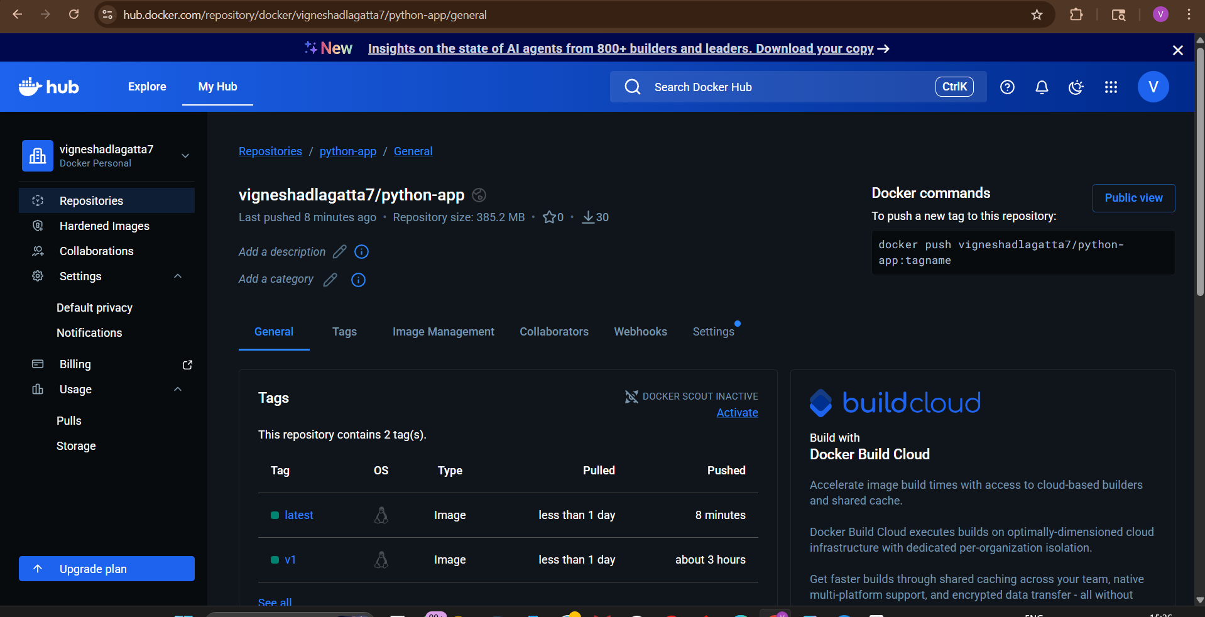
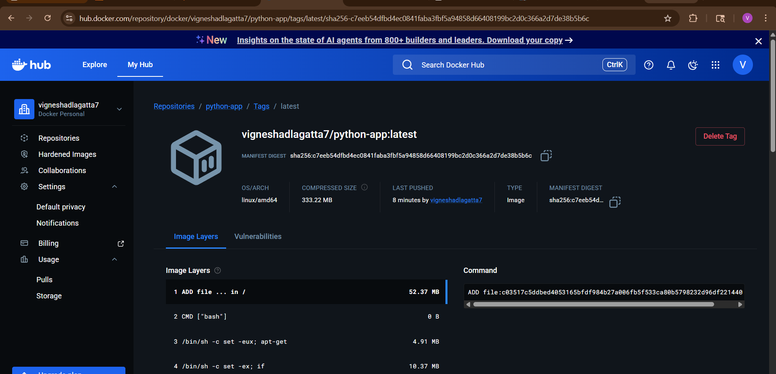

6) Source Codes: https://github.com/betawins/docker-tasks.git
From the frontend source code, write a Dockerfile, build a Docker image, run it, and push that image to your Docker registry.

1. Understand the Frontend App
From typical betawins/docker-tasks repo structure, the frontend is usually:
- HTML / React / Node-based UI
- Runs on a web server (like Nginx or Node)
We’ll assume:
- Static frontend (HTML/JS) OR React build

- 1. 1 Git Clone
git clone https://github.com/betawins/docker-tasks.git
cd docker-tasks
🔹 2. Write Dockerfile (Frontend)
vi Dockerfile
Paste Here
FROM nginx:alpine
# Remove default nginx content
RUN rm -rf /usr/share/nginx/html/*
# Copy frontend files
COPY Frontend_based_source/ /usr/share/nginx/html/
# Expose port
EXPOSE 80
# Start nginx
CMD ["nginx", "-g", "daemon off;"]
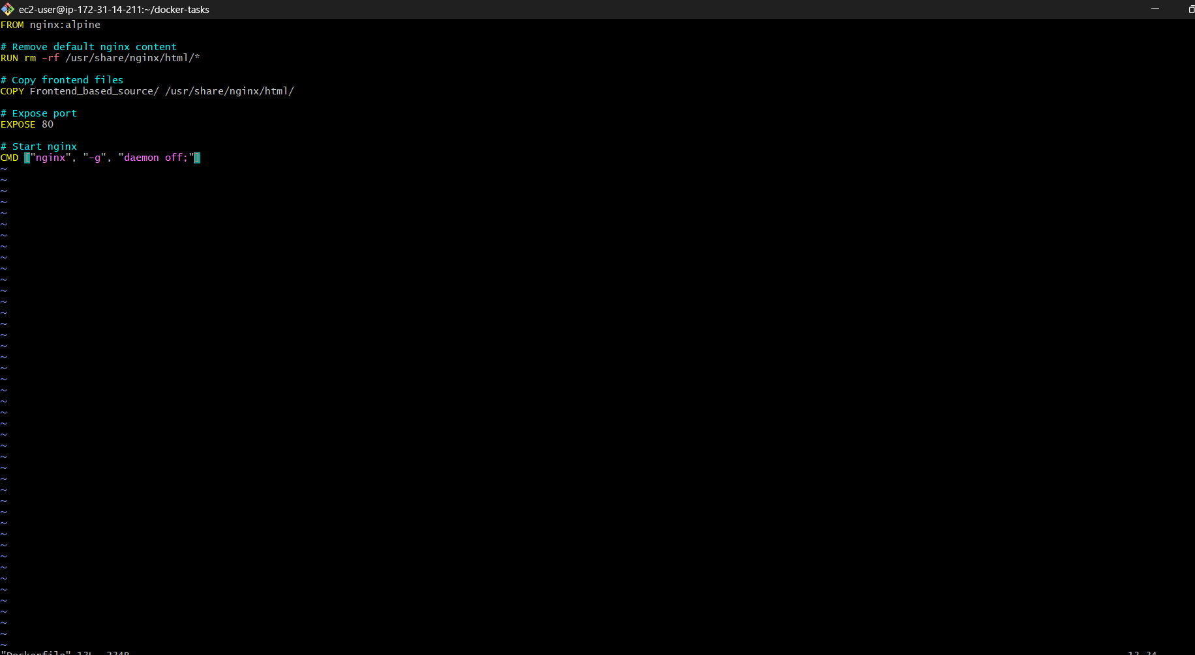

🔹 3. Build Docker Image
docker build -t yourdockerhubusername/frontend-app .
Example:
docker build -t vignesh123/frontend-app .
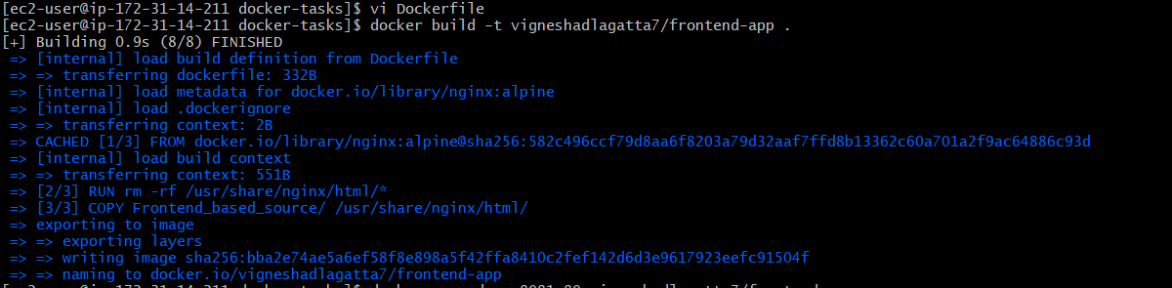

🔹 4. Run Container
docker run -d -p 8081:80 yourdockerhubusername/frontend-app

Access:
http://<EC2-IP>:8081


🔹 5. Login to Docker Hub
docker login
Enter:
- Username
- Password / Token
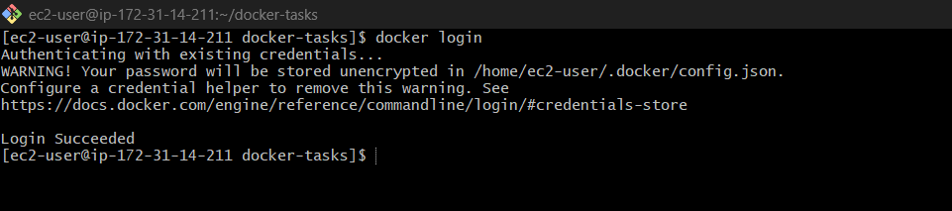

🔹 6. Tag Image
docker tag frontend-app yourdockerhubusername/frontend-app:latest

🔹 7. Push Image to Docker Hub
docker push yourdockerhubusername/frontend-app:latest

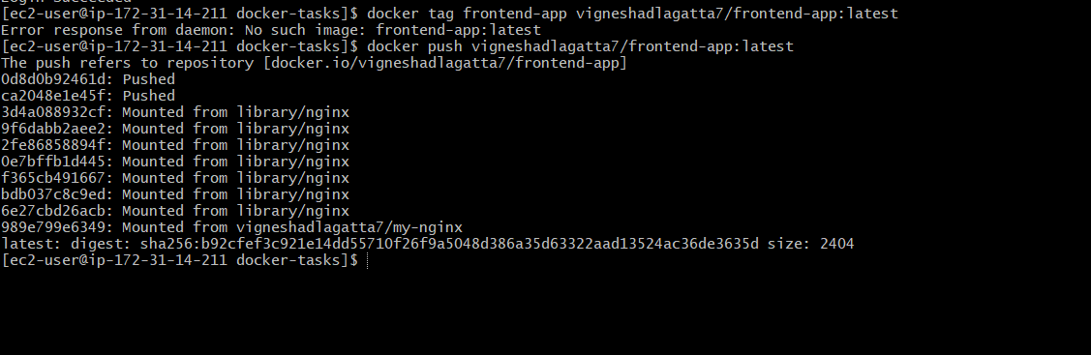

docker images
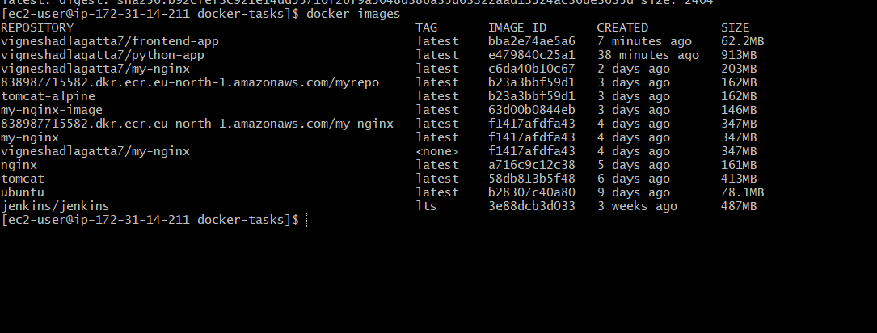
Verify In Docker HUB
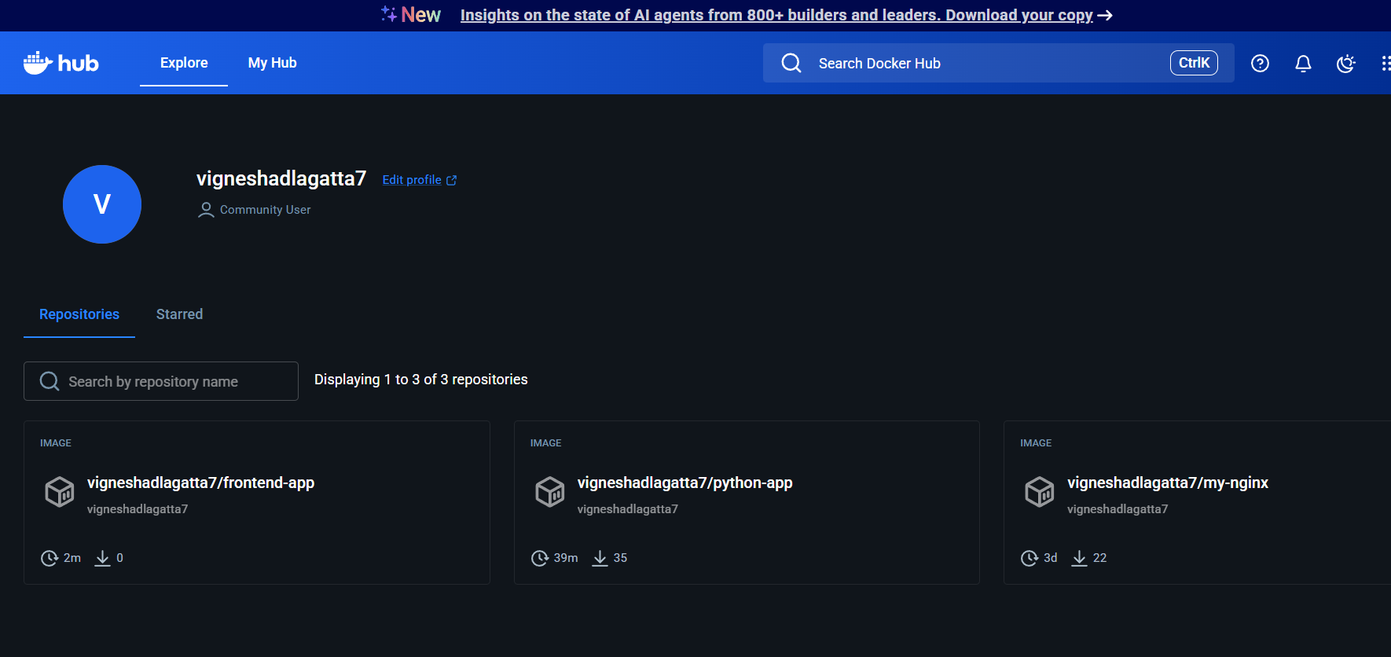
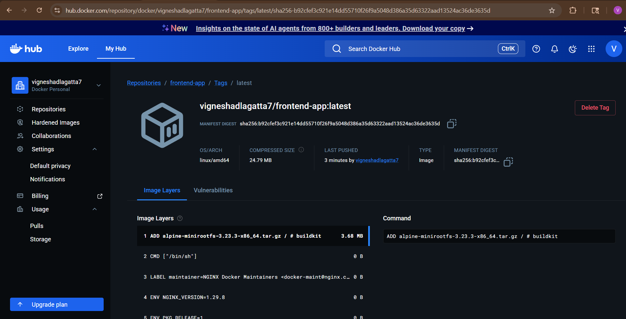

Final Flow
- Wrote Dockerfile using Nginx (or multi-stage for React)
- Built image using docker build
- Ran container using docker run
- Logged into Docker Hub
- Tagged image
- Pushed image to Docker registry

7) Source Codes: https://github.com/betawins/docker-tasks.git

From the Java-based source code, write a Dockerfile, build, run, and push the image to the Docker registry.

1. Clone the Repository
git clone https://github.com/betawins/docker-tasks.git
cd docker-tasks/Java_based_source

2. Understand Project (VERY IMPORTANT)
This is a Java Maven-based project, so:
- pom.xml → Maven build file
- Source code → src/
- Output → .jar file
So flow:
Java code → Maven build → JAR → Docker image

3. Write Dockerfile (Multi-stage - Best Practice)
Create a file named Dockerfile:
vi Dockerfile1
paste Here:
# Stage 1: Build the application
FROM maven:3.8.6-eclipse-temurin-11 AS builder
WORKDIR /app
# Copy pom first for better caching
COPY pom.xml .
# Download dependencies
RUN mvn dependency:go-offline
# Copy source code
COPY src ./src
# Build jar
RUN mvn clean package -DskipTests
# Stage 2: Run the application
FROM eclipse-temurin:11-jre
WORKDIR /app
# Copy built jar from builder stage
COPY --from=builder /app/target/*.jar app.jar
EXPOSE 8080
ENTRYPOINT ["java", "-jar", "app.jar"]
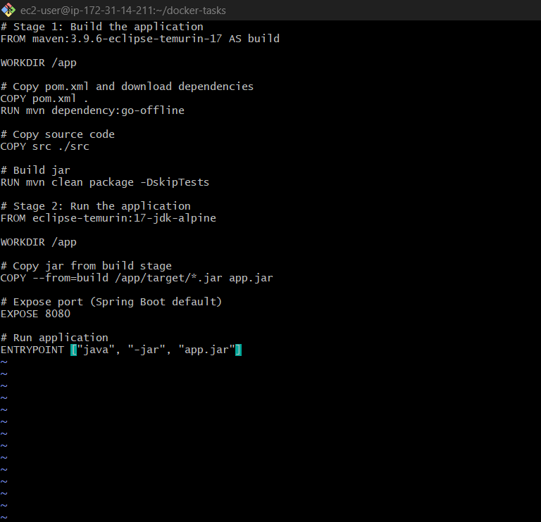

Why multi-stage?
- Smaller image
- Secure (no Maven in final image)
- Industry best practice

4. Build Docker Image
docker build -t your-dockerhub-username/java-spring-app:latest .

Example:
docker build -t vignesh123/ java-spring-app:latest .

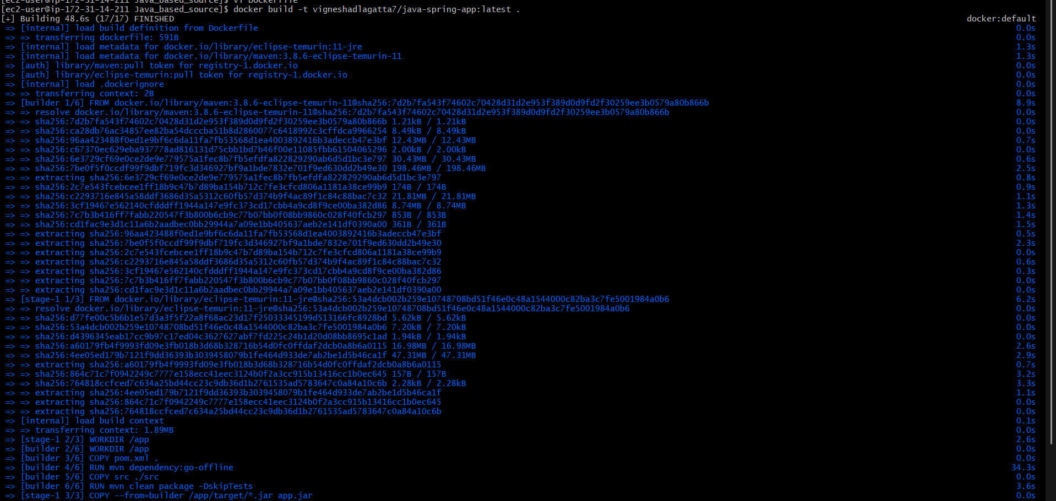
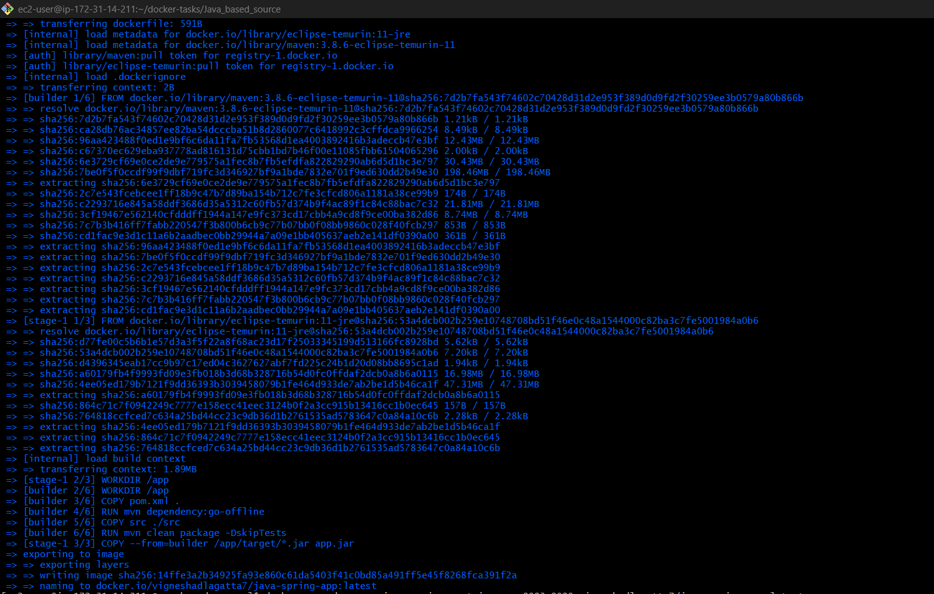

5. Run Container
docker run -d --name java-spring-container -p 8083:8080 your-dockerhub-username/java-spring-app:latest

Check:
docker ps
👉 Open browser:
http://<EC2-IP>:8083

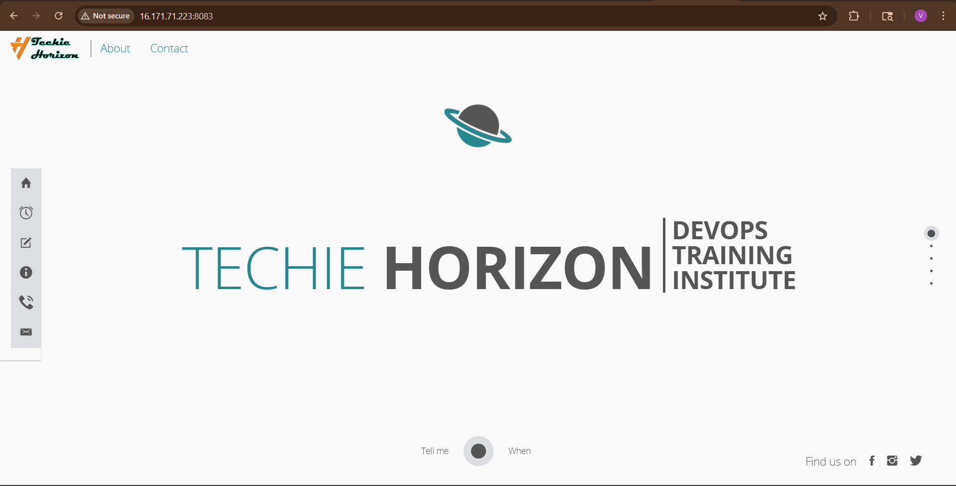
Push to Docker Hub
First login:
docker login

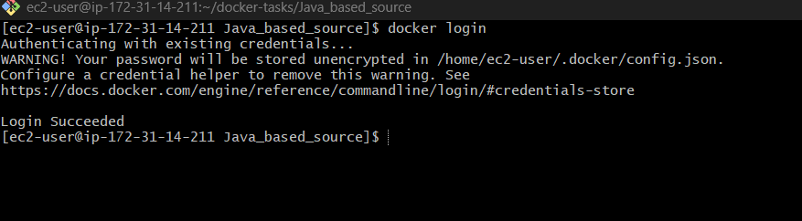

Push the image:
docker push your-dockerhub-username/java-spring-app:latest
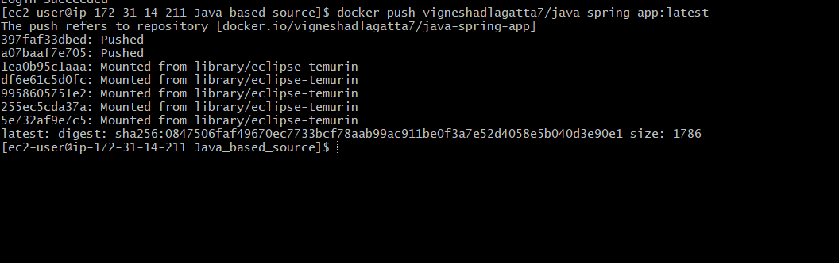
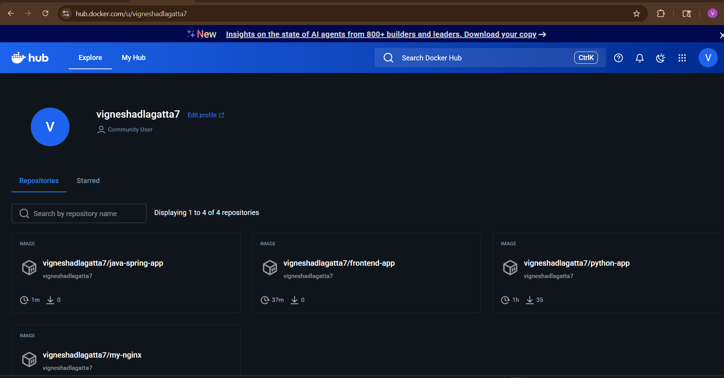
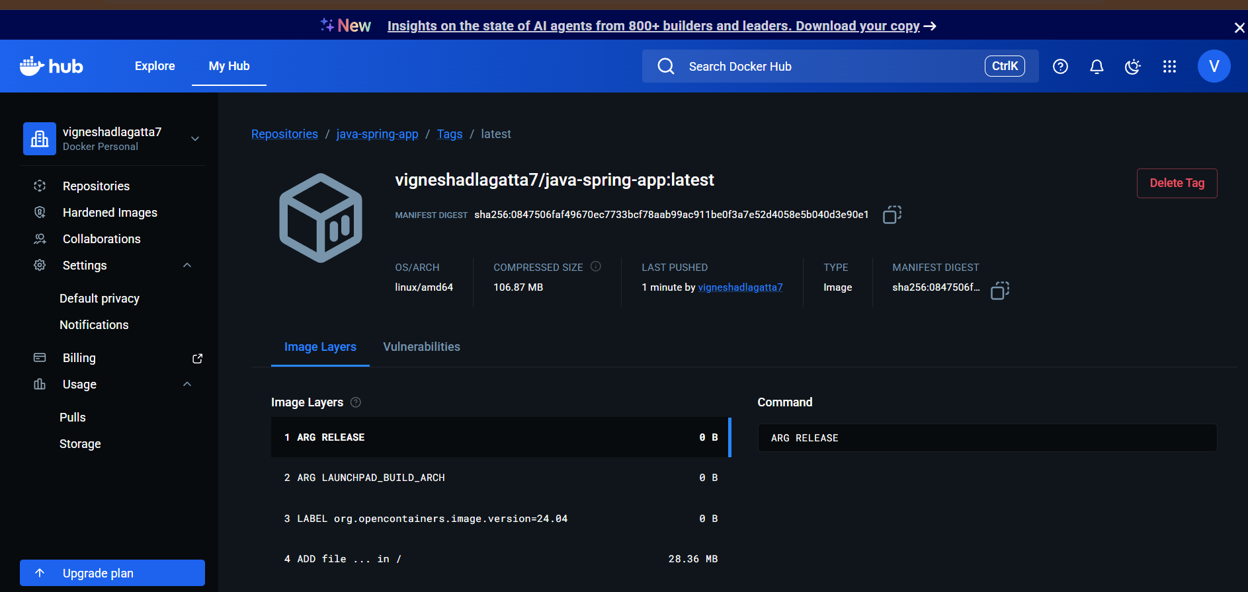

8) Source Codes: https://github.com/betawins/docker-tasks.git

From the Node.js-based source code, write a Dockerfile, build with tag v1, run, and push it to the Docker registry.

1. Clone the Repository
git clone https://github.com/betawins/docker-tasks.git
cd docker-tasks/NodeJs_based_source
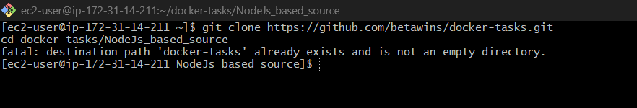

2) Write Dockerfile
Create a file named Dockerfile:
vi Dockerfile
paste Here:

# Stage 1: Build the React app
FROM node:18-alpine AS builder
WORKDIR /app
# Copy dependency files first
COPY package*.json ./
# Install dependencies
RUN npm install
# Copy source code
COPY . .
# Build production files
RUN npm run build
# Stage 2: Serve with Nginx
FROM nginx:alpine

# Remove default nginx static files
RUN rm -rf /usr/share/nginx/html/*
# Copy build output from builder stage
COPY --from=builder /app/build /usr/share/nginx/html
# Expose nginx port
EXPOSE 80
# Start nginx
CMD ["nginx", "-g", "daemon off;"]

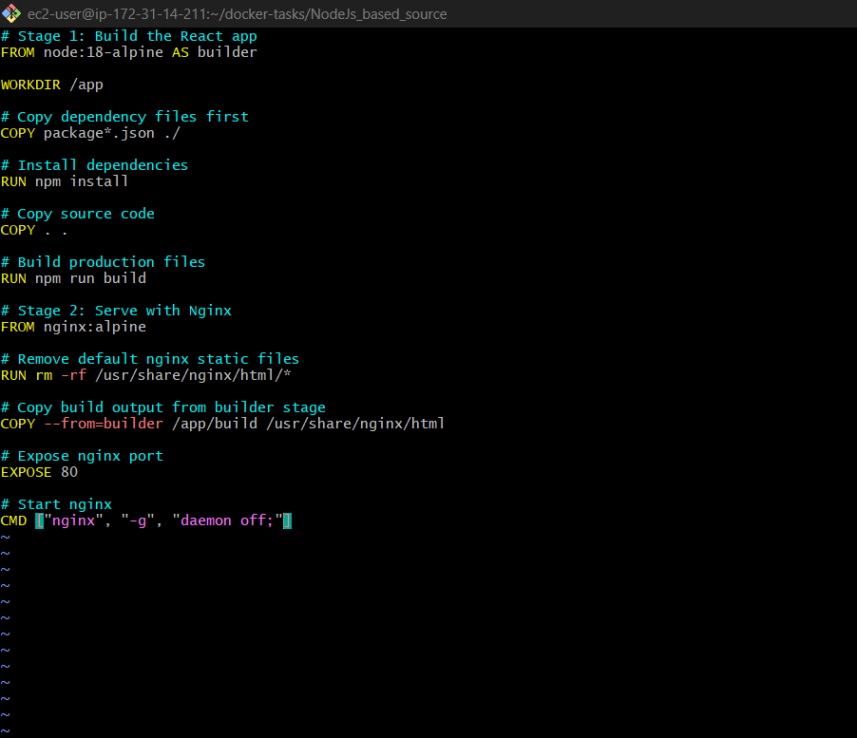

3) Build image with tag v1
docker build -t yourdockerhubusername/nodejs-app:v1 .

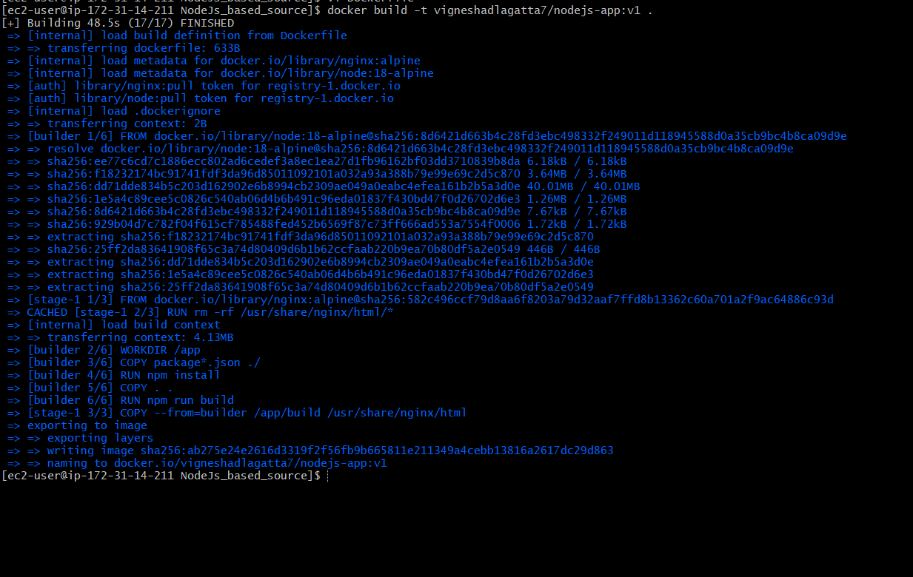

4) Run the container
docker run -d --name nodejs-app -p 3000:80 yourdockerhubusername/nodejs-app:v1
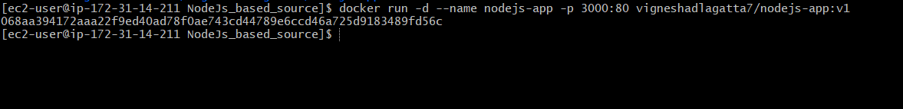
5) docker ps
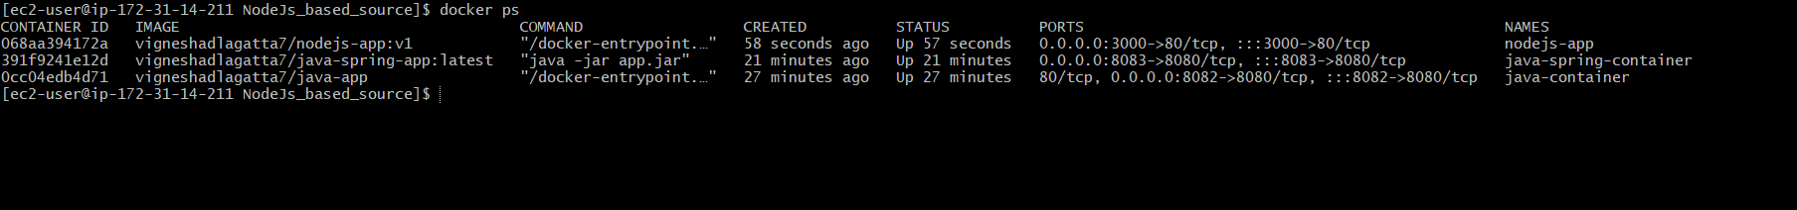

Open in browser:
http://localhost:3000
If you are using an EC2 server, open:
http://<EC2-PUBLIC-IP>:3000



Push to Docker registry
First log in:
docker login

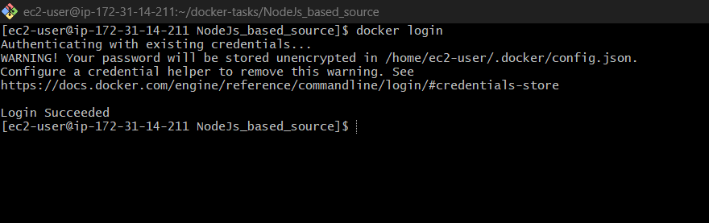

Then push:
docker push yourdockerhubusername/nodejs-app:v1
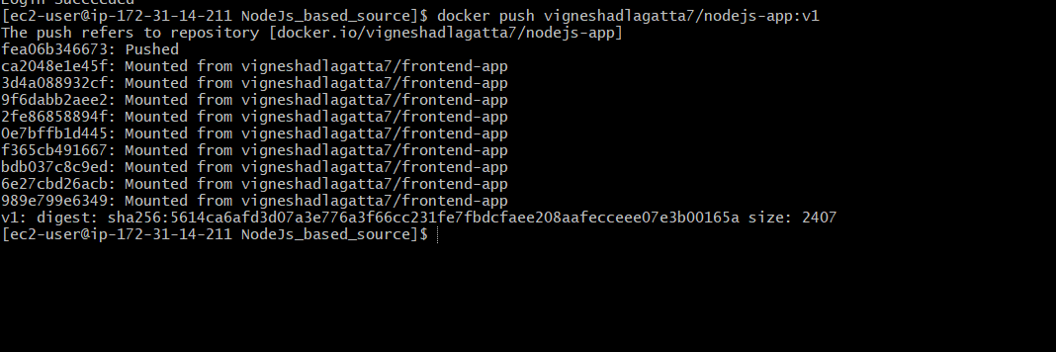
Verify In Docker HUB
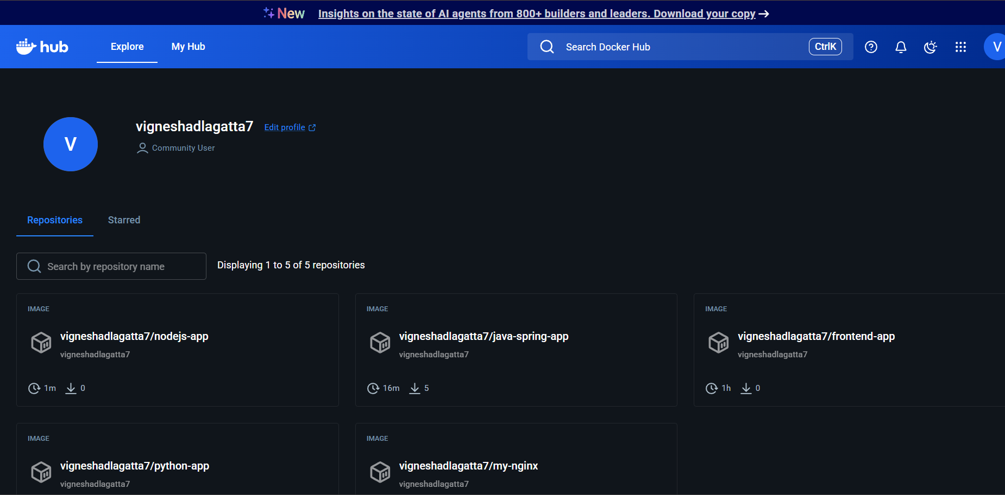
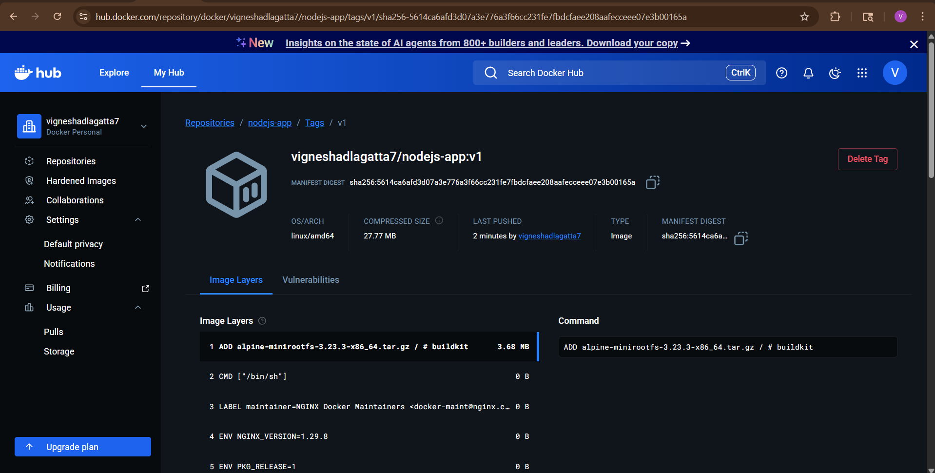

9) Write a docker-compose file to set up WordPress with a MySQL database.

1) Write Dockerfile
Create a file named docker-compose.yml:
vi docker-compose.yml
paste Here:

version: '3.8'
services:
db:
image: mysql:5.7
container_name: wordpress-db
restart: always
environment:
MYSQL_DATABASE: wordpress
MYSQL_USER: wpuser
MYSQL_PASSWORD: wppassword
MYSQL_ROOT_PASSWORD: rootpassword
volumes:
- db_data:/var/lib/mysql
wordpress:
image: wordpress:latest
container_name: wordpress-app
depends_on:
- db
restart: always
ports:
- "8080:80"
environment:
WORDPRESS_DB_HOST: db:3306
WORDPRESS_DB_NAME: wordpress
WORDPRESS_DB_USER: wpuser
WORDPRESS_DB_PASSWORD: wppassword
volumes:
- wordpress_data:/var/www/html
volumes:
db_data:
wordpress_data:

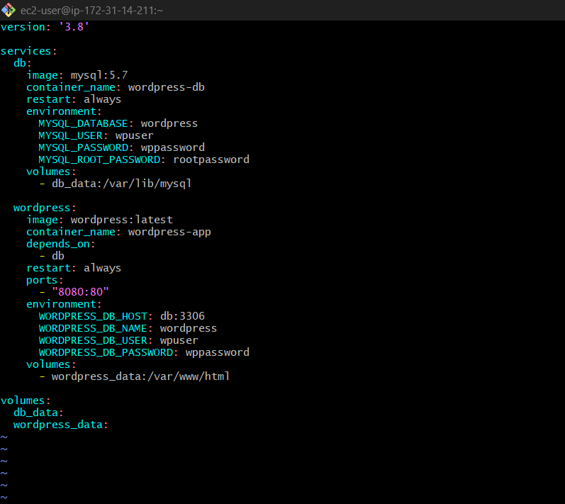

Save it as docker-compose.yml, then run:

docker-compose up -d

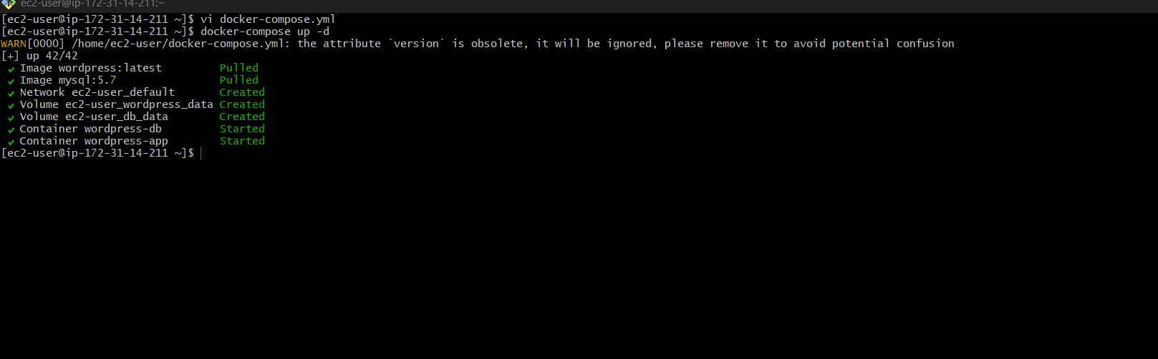
Open in browser:
http://localhost:8084
If you are using a cloud server, replace localhost with your server IP:
http://your-server-ip:8084
